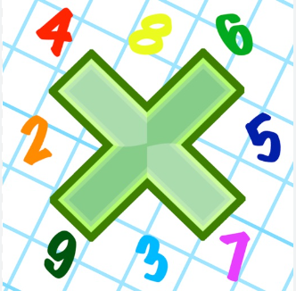
Reading: Please make sure you are reading at home at least 5 times each week. Daily reading is important for language and comprehension development. You child is provided with a reading book and a book of their choice from school.


Times Table: Practise your times tables (including division) wherever possible at home to aid fluency and accuracy with maths.
Homework task: Your homework task for this week is reading comprehension. Please complete the task on the sheet.

Please also complete the spelling sheet provided. These activities are based around the spellings the children have been learning this week and will help to address any misconceptions.

Vehicle _____________ _____________ _______________

Accommodate _____________ _____________ _______________

Achieve _____________ _____________ _______________

Ancient _____________ _____________ _______________

Bruise _____________ _____________ _______________

Category _____________ _____________ _______________

Cemetery _____________ _____________ _______________

Definite _____________ _____________ _______________

Desperate _____________ _____________ _______________

Develop _____________ _____________ _______________

Dictionary _____________ _____________ _______________

