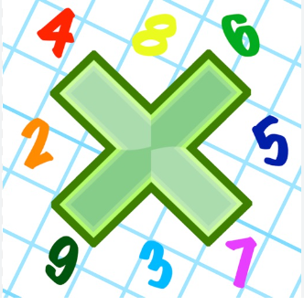
Reading: Please make sure you are reading at home at least 5 times each week. Daily reading is important for language and comprehension development. You child is provided with a reading book and a book of their choice from school.

Times Table: Practise your times tables (including division) wherever possible at home to aid fluency and accuracy with maths.

Spellings: conductor, insulator, volts, cells, invasion



Homework task: Your homework task for this week is comprehension. Please compete the comprehension provided by answering the questions on the sheet.
