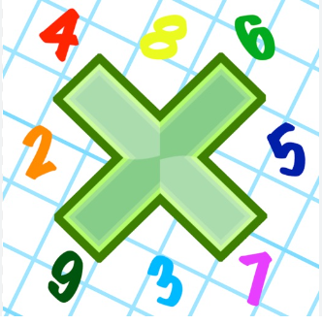
Reading: Please make sure you are reading at home at least 5 times each week. Daily reading is important for language and comprehension development. You child is provided with a reading book and a book of their choice from school.


Times Table: Practise your times tables (including division) wherever possible at home to aid fluency and accuracy with maths.
Homework task: Your homework task for this week is mathematics. Please complete the task on the sheet.

Please also complete the spelling sheet provided. These activities are based around the spellings the children have been learning this week and will help to address any misconceptions.

Embarrass _____________ _____________ _______________

Environment _____________ _____________ _______________

Exaggerate _____________ _____________ _______________

Existence _____________ _____________ _______________

Parliament _____________ _____________ _______________

Privilege _____________ _____________ _______________

Relevant _____________ _____________ _______________

Secretary _____________ _____________ _______________

Soldier _____________ _____________ _______________

Variety _____________ _____________ _______________

Vegetable _____________ _____________ _______________

