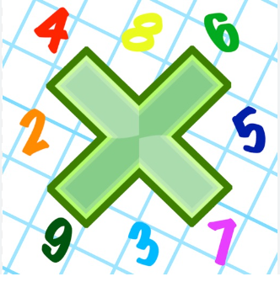
Reading: Please make sure you are reading at home at least 5 times each week. Daily reading is important for language and comprehension development. You child is provided with a reading book and a book of their choice from school.


Times Table: Practise your times tables (including division) wherever possible at home to aid fluency and accuracy with maths.
Homework task: Your homework task for this week is maths. Please complete the task on the sheet.

Please also complete the spelling sheet provided. These activities are based around the spellings the children have been learning this week and will help to address any misconceptions.

Experiment _____________ _____________ _______________

Experience _____________ _____________ _______________

Calendar _____________ _____________ _______________

Occasionally _____________ _____________ _______________

Through _____________ _____________ _______________

Certain _____________ _____________ _______________

Separate _____________ _____________ _______________

Believe _____________ _____________ _______________

Circle _____________ _____________ _______________

Ordinary _____________ _____________ _______________

Natural _____________ _____________ _______________

