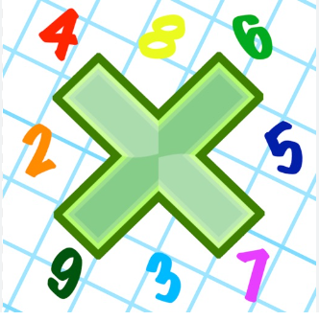
Reading: Please make sure you are reading at home at least 5 times each week. Daily reading is important for language and comprehension development. You child is provided with a reading book and a book of their choice from school.


Times Table: Practise your times tables (including division) wherever possible at home to aid fluency and accuracy with maths.
Homework task: Your homework task for this week is reading comprehension. Please complete the task on the sheet.

Please also complete the spelling sheet provided. These activities are based around the spellings the children have been learning this week and will help to address any misconceptions.

Attached _____________ _____________ _______________

Available _____________ _____________ _______________

Competition _____________ _____________ _______________

Determined _____________ _____________ _______________

Disastrous _____________ _____________ _______________

Equipment _____________ _____________ _______________

Especially _____________ _____________ _______________

Explanation _____________ _____________ _______________

Frequently _____________ _____________ _______________

Government _____________ _____________ _______________

Immediately _____________ _____________ _______________

