Reading: Please make sure you are reading at home at least 5 times each week. Daily reading is important for language and comprehension development. You child is provided with a reading book and a book of their choice from school.

Times Table: Practise your times tables (including division) wherever possible at home to aid fluency and accuracy with maths.
Homework task: Your homework task for this week is maths – comparing and ordering fractions. Please complete the task on the sheet.
Remember you need to have the same denominator before you can compare!
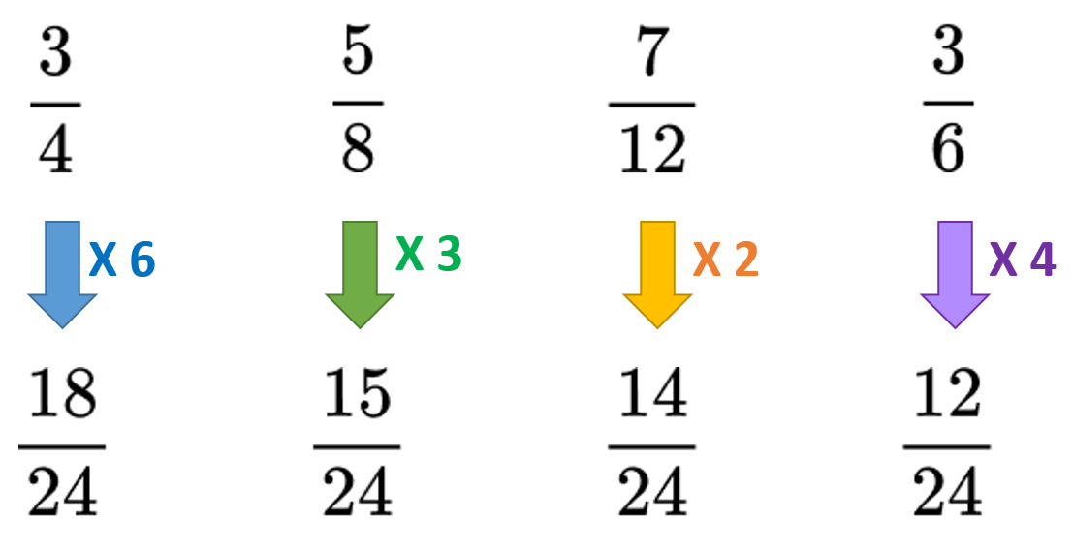

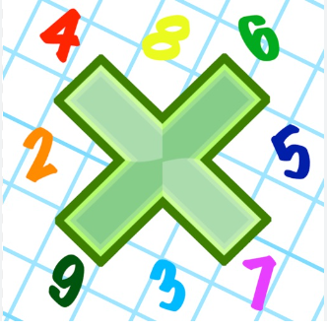
Marvellous _____________ _____________ _______________

Mischievous _____________ _____________ _______________

Muscle _____________ _____________ _______________

Physical _____________ _____________ _______________

Professions _____________ _____________ _______________

Pronunciation _____________ _____________ _______________

Rhyme _____________ _____________ _______________

Rhythm _____________ _____________ _______________

Sincere _____________ _____________ _______________

Sincerely _____________ _____________ _______________

Symbol _____________ _____________ _______________

