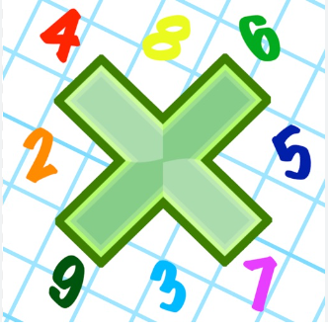
Reading: Please make sure you are reading at home at least 5 times each week. Daily reading is important for language and comprehension development. Your child is provided with a reading book and a book of their choice from school.


Times Table: Practise your times tables (including division) wherever possible at home to aid fluency and accuracy with Maths.

Reading: Please make sure you are reading at home at least 5 times each week. Daily reading is important for language and comprehension development. Your child is provided with a reading book and a book of their choice from school.

Times Table: Practise your times tables (including division) wherever possible at home to aid fluency and accuracy with Maths.

Reading: Please make sure you are reading at home at least 5 times each week. Daily reading is important for language and comprehension development. Your child is provided with a reading book and a book of their choice from school.

Times Table: Practise your times tables (including division) wherever possible at home to aid fluency and accuracy with Maths.

