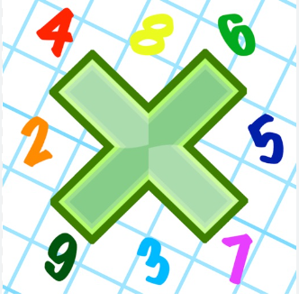
Reading: Please make sure you are reading at home at least 5 times each week. Daily reading is important for language and comprehension development. Your child is provided with a reading book and a book of their choice from school.


Times Table: Practise your times tables (including division) wherever possible at home to aid fluency and accuracy with Maths. Our focus next week will be our 2, 5 and 10’s.
Homework task:
Your homework task for this week is to cover your homework book and decorate it. You can use stickers, pictures, plastic covers or wrapping paper, however please do not draw on your books. Make sure we can see your name clearly and if you require any materials to help with covering your book, please see your class teacher who can help. Please see some examples below:

