Homework task: Your homework task for this week is to cover your homework book and decorate it.
You can decorate it with printed pictures, wrapping paper or stickers!


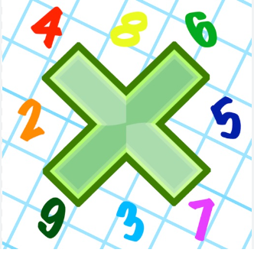
Reading: Please make sure you are reading at home at least 5 times each week. Daily reading is important for language and comprehension development. You child is provided with a reading book and a book of their choice from school.

Times Table: Practise your times tables (including division) wherever possible at home to aid fluency and accuracy with maths.

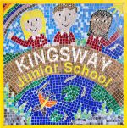

Kingsway Junior Homework Date: 6.09.22

Homework task: Your homework task for this week is to cover your homework book and decorate it.
You can decorate it with printed pictures, wrapping paper or stickers!

Reading: Please make sure you are reading at home at least 5 times each week. Daily reading is important for language and comprehension development. You child is provided with a reading book and a book of their choice from school.

Times Table: Practise your times tables (including division) wherever possible at home to aid fluency and accuracy with maths.

