Maths Homework 8.11.24

LO: To use rounding to estimate the answers to addition and subtraction calculations.

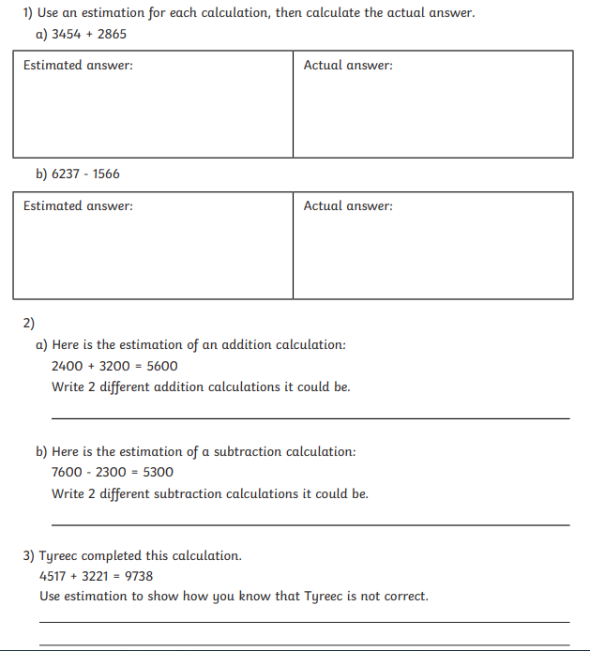

Maths Homework 8.11.24

LO: To use rounding to estimate the answers to addition and subtraction calculations.

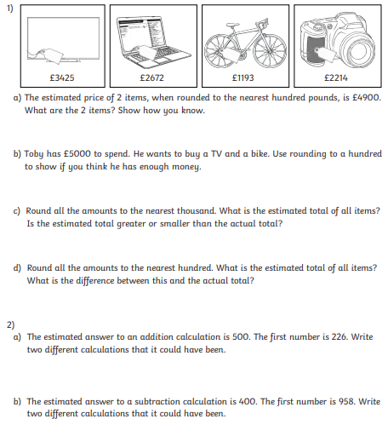

Maths Homework 8.11.24

LO: To use rounding to estimate the answers to addition and subtraction calculations.

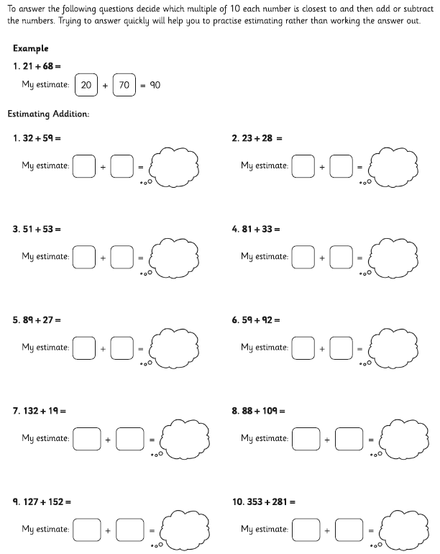

Maths Homework 8.11.24

LO: To use rounding to estimate the answers to addition and subtraction calculations.

