YEAR 5 HOMEWORK |  | 4 October 2024
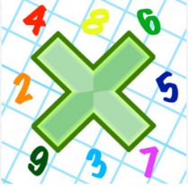
Reading: Please make sure you are reading at home at least 5 times each week. Daily reading is important for language and comprehension development.

Times Table: Practise your times tables (including division) wherever possible at home to aid fluency and accuracy with maths. This week go over your 6 x tables.

Spelling: Please complete the spelling sheets provided. These activities are based around the CUSP spellings the children have been learning this week and will help to address any misconceptions.

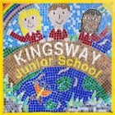 | This week you will complete a Maths homework relating to our learning this week on multiplying and dividing numbers by 10, 100, 1000. Complete the first two sections. The challenge questions are optional. |  | Signed by parent/carer:  ………………………

YEAR 5 HOMEWORK |  | 4 October 2024
Reading: Please make sure you are reading at home at least 5 times each week. Daily reading is important for language and comprehension development.

Times Table: Practise your times tables (including division) wherever possible at home to aid fluency and accuracy with maths. This week go over your 6 x tables.

Spelling: Please complete the spelling sheets provided. These activities are based around the CUSP spellings the children have been learning this week and will help to address any misconceptions.

 | This week you will complete a Maths homework relating to our learning this week on multiplying and dividing numbers by 10, 100, 1000. Complete the first two sections. The challenge questions are optional. |  | Signed by parent/carer:  ………………………

YEAR 5 HOMEWORK |  | 4 October 2024
Reading: Please make sure you are reading at home at least 5 times each week. Daily reading is important for language and comprehension development.

Times Table: Practise your times tables (including division) wherever possible at home to aid fluency and accuracy with maths. This week go over your 6 x tables.

Spelling: Please complete the spelling sheets provided. These activities are based around the CUSP spellings the children have been learning this week and will help to address any misconceptions.

 | This week you will complete a Maths homework relating to our learning this week on multiplying and dividing numbers by 10, 100, 1000. Complete the first two sections. The challenge is optional. |  | Signed by parent/carer:  ………………………

