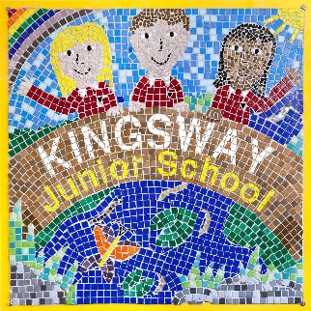**Year 3**

**Geography Champion quiz**

1. Which town do we live in?
2. What is the name of our county?
3. Name two counties next to us.
4. Which capital city are we close to?
5. Which 2 motorways are close to us?
6. Name two train stations nearby.
7. Name two parks in our area.
8. Which river runs through our town?
9. Which country do we live in?
10. Which continent is our country in?
11. Name 3 cities in the UK.
12. What are the 4 countries and capital cities in the UK?

|  |  |
| --- | --- |
| Country | Capital City |
|  |  |
|  |  |
|  |  |
|  |  |

1. Name 2 mountains in the UK.
2. Name 2 rivers in the UK.
3. Label: The English Channel

The North Sea

The Atlantic Ocean

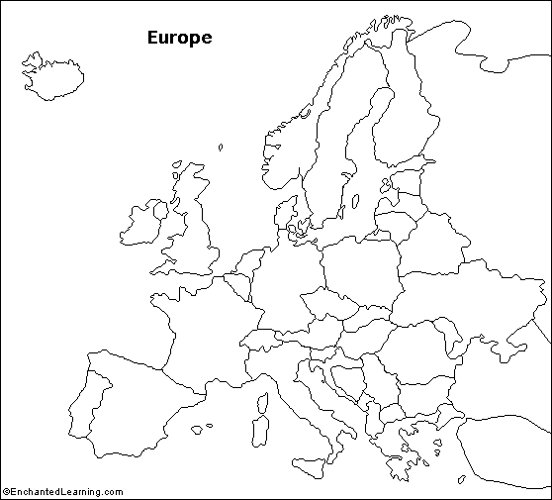

1. Fill in this table:

|  |  |
| --- | --- |
| Continent | 1 country in this continent |
|  |  |
|  |  |
|  |  |
|  |  |
|  |  |
|  |  |
|  |  |

       