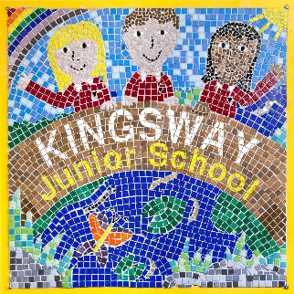**Year 5**

**Geography Champion quiz**

1. Which town do we live in?
2. What is the name of our county?
3. Which capital city are we close to?
4. Which 2 motorways are close to us?
5. Name two train stations nearby.
6. Name two parks in our area.
7. Which river runs through our town?
8. Which country do we live in?
9. Which continent is our country in?
10. Name 3 cities in the UK.
11. What are the 4 countries and capital cities in the UK?

|  |  |
| --- | --- |
| Country | Capital City |
|  |  |
|  |  |
|  |  |
|  |  |

1. Name 2 mountains in the UK.
2. Name 2 rivers in the UK.
3. Label: The English Channel

The North Sea

The Atlantic Ocean

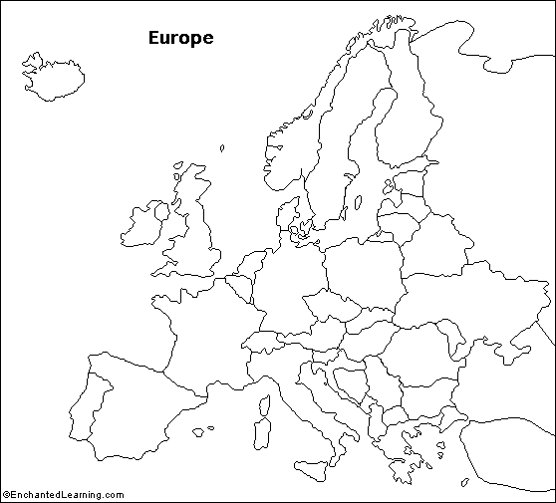

1. Fill in this table:

|  |  |
| --- | --- |
| Continent | 1 country in this continent |
|  |  |
|  |  |
|  |  |
|  |  |
|  |  |
|  |  |
|  |  |

1. Describe the location of Europe compared to other continents.
2. Fill in this table:

|  |  |
| --- | --- |
| European country | Capital City |
|  |  |
|  |  |
|  |  |
|  |  |
|  |  |
|  |  |
|  |  |

1. Where is the Mediterranean Sea?
2. Name 4 countries within the Mediterranean region.
3. Where is the source of the River Thames?
4. Where is the mouth of the Thames?
5. Which capital city does the Thames flow through?

|  |  |  |
| --- | --- | --- |
| UK Country | River | Mountain |
|  |  |  |
|  |  |  |
|  |  |  |
|  |  |  |

1. Name 4 counties in England.

|  |  |
| --- | --- |
| North American countries | South American Countries |
|  |  |
|  |  |
|  |  |
|  |  |

1. Describe the location of Yucatan region.

1. Yucatan is _______________ of the equator.

