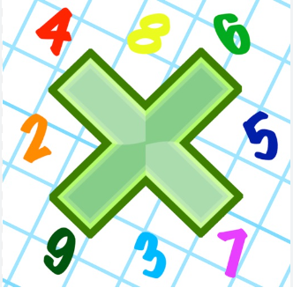
Reading: Please make sure you are reading at home at least 5 times each week. Daily reading is important for language and comprehension development. You child is provided with a reading book and a book of their choice from school.


Times Table: Practise your times tables (including division) wherever possible at home to aid fluency and accuracy with maths.
Homework task:
Your homework task for this week is Maths. Please compete the maths sheets on timestable word problems. . Please read all the questions carefully and use your arrays to help you solve them.
The extra for experts is optional but there will be house points for effort!

Please also complete the spelling sheet provided. These activities are based around the spellings the children have been learning this week and will help to address any misconceptions.

