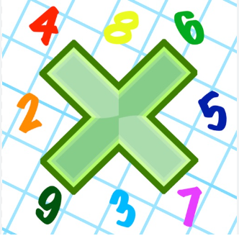
Reading: Please make sure you are reading at home at least 5 times each week. Daily reading is important for language and comprehension development. You child is provided with a reading book and a book of their choice from school.


Times Table: Practise your times tables (including division) wherever possible at home to aid fluency and accuracy with maths.
Homework task: Your homework task for this week is English comprehension. Please read the text and answer the questions carefully.

Please practise the Year 6 Statutory Spellings. They should be written in your books 3 times.

- Attached
- Available
- Competition
- Determined
- Disastrous
- Equipment
- Especially
- Explanation
- Frequently
- Government

