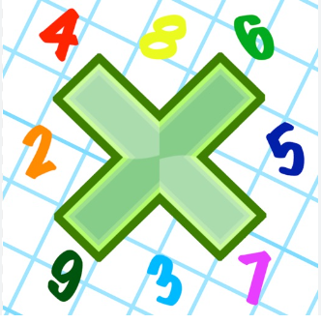
Reading: Please make sure you are reading at home at least 5 times each week. Daily reading is important for language and comprehension development. Your child is provided with a reading book and a book of their choice from school.


Times Table: Practise your times tables (including division) wherever possible at home to aid fluency and accuracy with maths. Please continue to practise your 2, 5 and 10 times tables to aid with your learning next week.
Homework task:
Your homework task for this week is comprehension. Please complete the comprehension provided by answering the VIPERS questions from the sheet in your book using the lines. Remember to read the text carefully and use evidence from the text to answer the questions.

Please also complete the spelling sheet provided. These activities are based around the spellings the children have been learning this week and will help to address any misconceptions.
