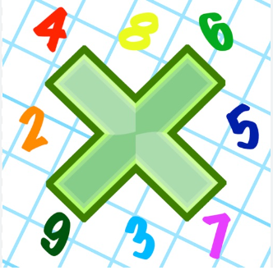
Reading: Please make sure you are reading at home at least 5 times each week. Daily reading is important for language and comprehension development. You child is provided with a reading book and a book of their choice from school.


Times Table: Practise your times tables (including division) wherever possible at home to aid fluency and accuracy with maths.
Homework task: Your homework tasks for this week are an arithmetic sheet and a Science project. For science, you need to draw or make an animal or your choice and research the classification for that animal. This includes its:

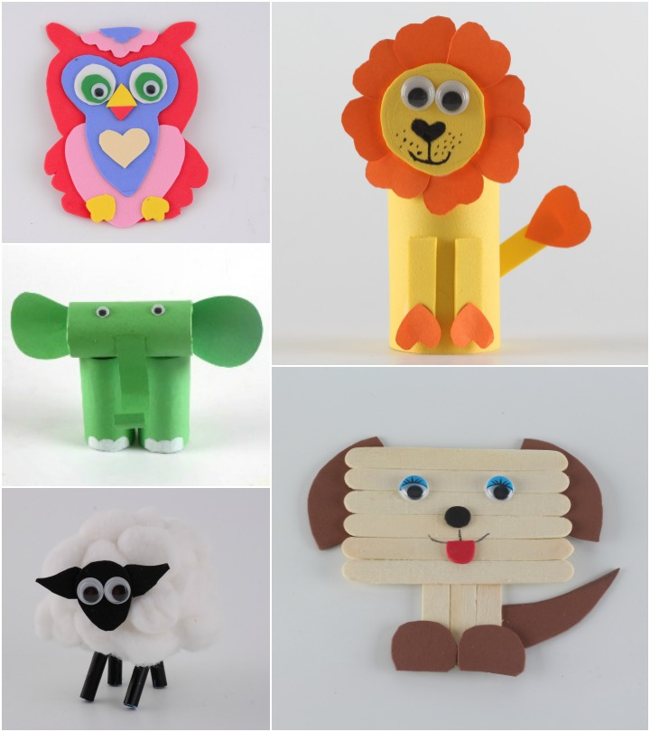
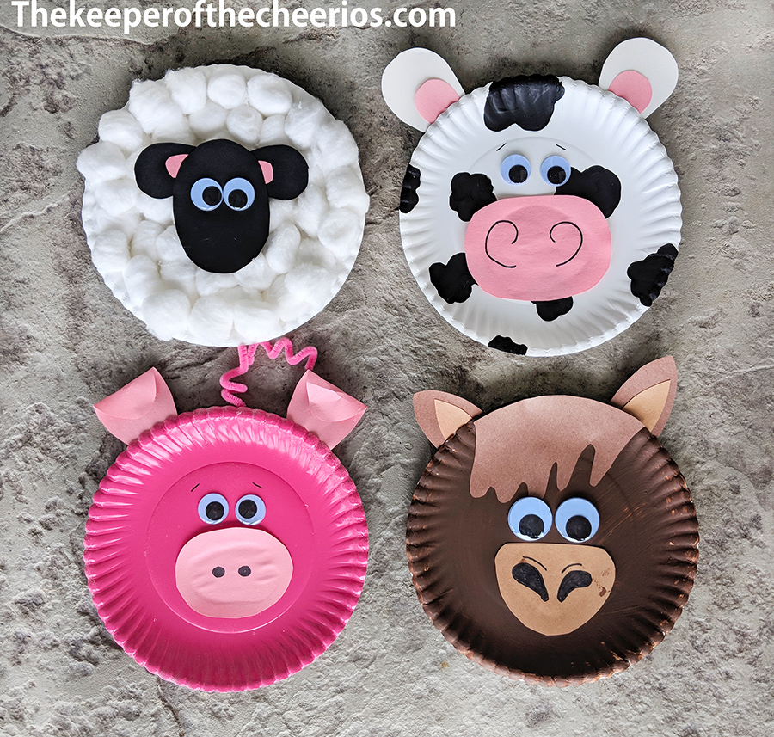
Domain
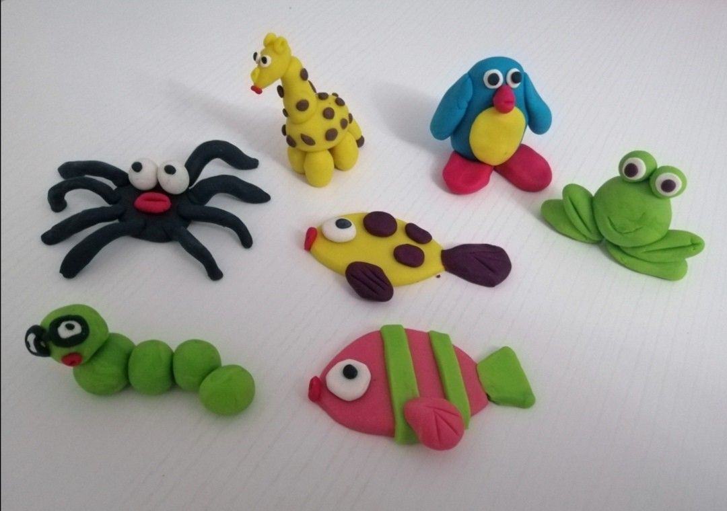
Kingdom
Phylum
Class
Order
Suborder
Animal Families
Genus
Species

You may choose to draw your animal or make it out of paper, card, fabric, modelling dough ect.

