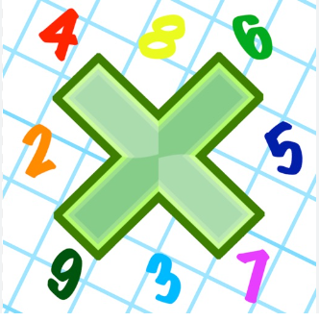
Reading: Please make sure you are reading at home at least 5 times each week. Daily reading is important for language and comprehension development. You child is provided with a reading book and a book of their choice from school.


Times Table: Practise your times tables (including division) wherever possible at home to aid fluency and accuracy with maths.
Homework task: Your homework tasks for this week are an arithmetic sheet and a Science project. For science, you need to draw or make a model of our solar system and find the key facts about each planet.

This includes its:
Name
Distance from the sun
Temperature
How long it takes to orbit the sun
The names of any moons

You may choose to draw your solar system or make it out of paper, card, fabric, modelling dough ect.
