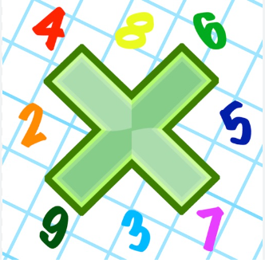
Reading: Please make sure you are reading at home at least 5 times each week. Daily reading is important for language and comprehension development. You child is provided with a reading book and a book of their choice from school.

Spellings: Please also complete the spelling sheet provided. These activities are based around the spellings the children have been learning this week and will help to address any misconceptions.


Times Table: Practise your times tables (including division) wherever possible at home to aid fluency and accuracy with maths. If possible please used Timestables Rockstars.
Homework task: Your homework task for this half term is liniked to Science. This half term Year 3 have been looking at animals including humans – animal skeletons, the human body, muscles and bones. Please try create either an information booklet, a presentation or a poster about the human body or animal bodies and how they functions. It may be about how to keep our muscles strong, how different animals have different skeletons and why, you might take pictures of different activities to look after our physical bodies or about the human skeleton and its functions. If you need any additional support, please see your class teacher before Wednesday 28th February. 