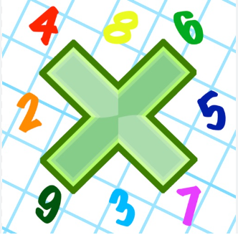
Reading: Please make sure you are reading at home at least 5 times each week. Daily reading is important for language and comprehension development. You child is provided with a reading book and a book of their choice from school.


Times Table: Practise your times tables (including division) wherever possible at home to aid fluency and accuracy with maths.
Homework task: Your homework task for this week is matahematics. Please complete the task on the sheet.

Please also complete the spelling sheet provided. These activities are based around the spellings the children have been learning this week and will help to address any misconceptions.

Vegetable _____________ _____________ _______________

Accompany _____________ _____________ _______________

According _____________ _____________ _______________

Aggressive _____________ _____________ _______________

Apparent _____________ _____________ _______________

Appreciate _____________ _____________ _______________

Awkward _____________ _____________ _______________

Committee _____________ _____________ _______________

Community _____________ _____________ _______________

Controversy _____________ _____________ _______________

Correspond _____________ _____________ _______________

