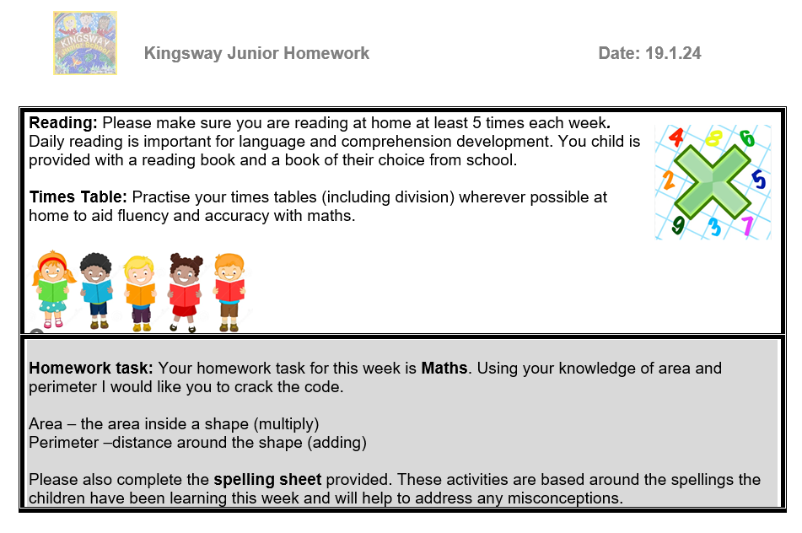

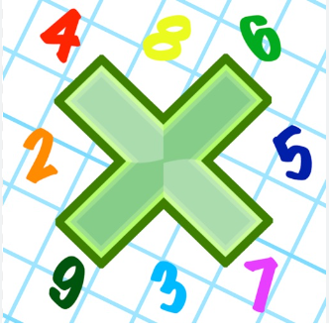
Reading: Please make sure you are reading at home at least 5 times each week. Daily reading is important for language and comprehension development. You child is provided with a reading book and a book of their choice from school.


Times Table: Practise your times tables (including division) wherever possible at home to aid fluency and accuracy with maths.
Homework task: Your homework task for this week is Maths. Using your knowledge of area and perimeter I would like you to crack the code.

Area – the area inside a shape (multiply)
Perimeter –distance around the shape (adding)

Please also complete the spelling sheet provided. These activities are based around the spellings the children have been learning this week and will help to address any misconceptions.

