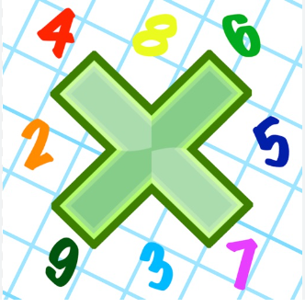
Reading: Please make sure you are reading at home at least 5 times each week. Daily reading is important for language and comprehension development. You child is provided with a reading book and a book of their choice from school.

Spelling: Please complete the home learning spelling worksheet.


Times Table: Practise your times tables (including division) wherever possible at home to aid fluency and accuracy with maths. If possible please used Timestables Rockstars.
Homework task: Your homework task for this week is comprehension. Please compete the comprehension provided by answering the questions on the sheet. Please complete section A and B, section C is optional but there will be house points for effort!

