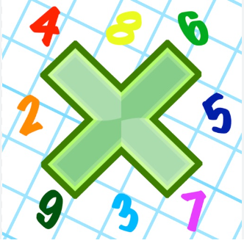
Reading: Please make sure you are reading at home at least 5 times each week. Daily reading is important for language and comprehension development. You child is provided with a reading book and a book of their choice from school.

Spelling: Please complete the home learning spelling worksheet.


Times Table: Practise your times tables (including division) wherever possible at home to aid fluency and accuracy with maths.
Homework task: Your homework task for this week is maths. Please compete the symmetrical drawings on the sheet. If you need any additional support, please see your class teacher before Wednesday 24th January.

This term, we are using recycled materials for art. Please can you bring in any cardboard boxes, toilet roll tubes, plastic bottles etc.

