**Maths Homework 10/1/25**

**LO: To be able to divide 2-,3- and 4- digit numbers using bus stop method and be able to express remainders as fractions.**

**Remember to write your remainders as fractions.**

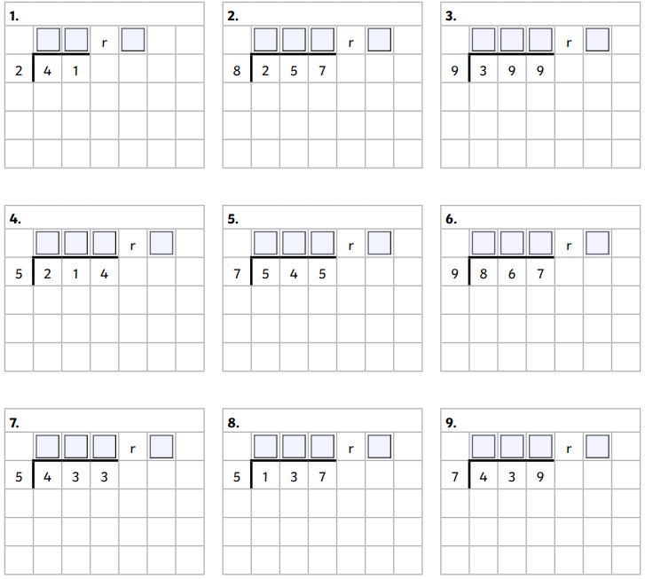

**Challenge**

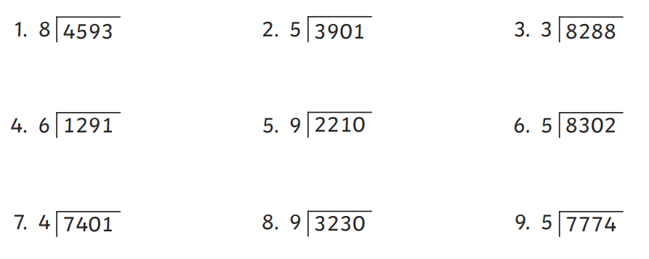

**Extension**

