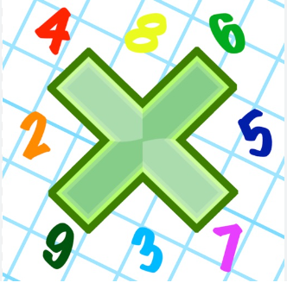
Reading: Please make sure you are reading at home at least 5 times each week. Daily reading is important for language and comprehension development. You child is provided with a reading book and a book of their choice from school.

Spelling: Please complete the spelling sheet provided.


Times Table: Practise your times tables (including division) wherever possible at home to aid fluency and accuracy with maths. If possible please used Timestables Rockstars.
Complete the timestable sheet given in replacement of spellings.
Homework task: Your homework task for this week is maths. Please compete the maths questions on graphs by answering the questions in your book. If you have any problems please see your class teacher before Thursday 16th May.



Reading: Please make sure you are reading at home at least 5 times each week. Daily reading is important for language and comprehension development. You child is provided with a reading book and a book of their choice from school.

Spelling: Please complete the spelling sheet provided.

Times Table: Practise your times tables (including division) wherever possible at home to aid fluency and accuracy with maths. If possible please used Timestables Rockstars.
Complete the timestable sheet given in replacement of spellings.
Homework task: Your homework task for this week is maths. Please compete the maths questions on graphs by answering the questions in your book. If you have any problems please see your class teacher before Thursday 16th May.

