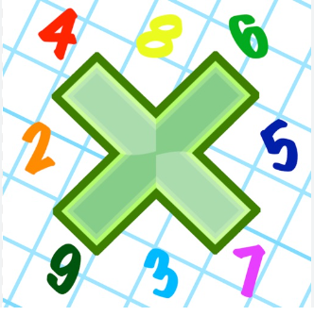
Reading: Please make sure you are reading at home at least 5 times each week. Daily reading is important for language and comprehension development. You child is provided with a reading book and a book of their choice from school.


Times Table: Practise your times tables (including division) wherever possible at home to aid fluency and accuracy with maths.
Homework task: Your homework task for this week is maths. Please compete task on the sheet.

Please also complete the spelling sheet provided. These activities are based around the spellings the children have been learning this week and will help to address any misconceptions.

Foreign _____________ _____________ _______________

Leisure _____________ _____________ _______________

Lightning _____________ _____________ _______________

Neighbour _____________ _____________ _______________

Occupy _____________ _____________ _______________

Occur _____________ _____________ _______________

Opportunity _____________ _____________ _______________

Stomach _____________ _____________ _______________

Sufficient _____________ _____________ _______________

Suggest _____________ _____________ _______________

Thorough _____________ _____________ _______________

