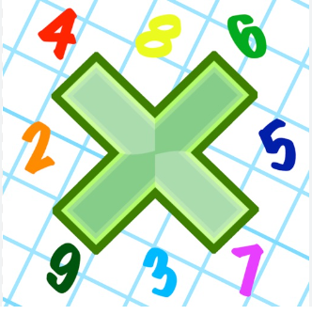
Reading: Please make sure you are reading at home at least 5 times each week. Daily reading is important for language and comprehension development. You child is provided with a reading book and a book of their choice from school.


Times Table: Practise your times tables (including division) wherever possible at home to aid fluency and accuracy with maths.
Homework task: Your homework task for this week is reading comprehension. Please compete the task on the sheet.

Please also complete the spelling sheet provided. These activities are based around the spellings the children have been learning this week and will help to address any misconceptions.

Twelth _____________ _____________ _______________

Yacht _____________ _____________ _______________

Amateur _____________ _____________ _______________

Bargain _____________ _____________ _______________

Communicate _____________ _____________ _______________

Conscience _____________ _____________ _______________

Conscious _____________ _____________ _______________

Criticize _____________ _____________ _______________

Excellent _____________ _____________ _______________

Familiar _____________ _____________ _______________

Forty _____________ _____________ _______________

