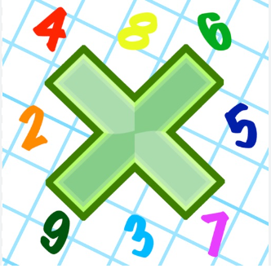
Reading: Please make sure you are reading at home at least 5 times each week. Daily reading is important for language and comprehension development. You child is provided with a reading book and a book of their choice from school.


Times Table: Practise your times tables (including division) wherever possible at home to aid fluency and accuracy with maths.
Homework task: Your homework task for this week is comprehension. Please compete the comprehension provided by answering the questions on the sheet.

Please also complete the spelling sheet provided. These activities are based around the spellings the children have been learning this week and will help to address any misconceptions.

Neighbour ____________ ____________ ______________
Occupy ____________ ____________ ______________
Occur ____________ ____________ ______________
Opportunity ____________ ____________ _____________
Stomach ____________ ____________ ______________
Sufficient ____________ ____________ ______________
Suggest ____________ ____________ ______________
Thorough ____________ ____________ ______________
Twelfth ____________ ____________ ______________
Yacht ____________ ____________ ______________

