YEAR 5 HOMEWORK |  | 3rd MAY 2024
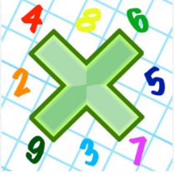
Reading: Please make sure you are reading at home at least 5 times each week. Daily reading is important for language and comprehension development.

Times Table: Practise your times tables (including division) wherever possible at home to aid fluency and accuracy with maths.

Spelling: Please complete the spelling sheet provided. These activities are based around the CUSP spellings the children have been learning this week and will help to address any misconceptions.

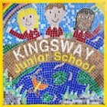 | Your English homework for this week is a comprehension activity. Complete all sections of the comprehension. |  | Signed by parent/carer:  ………………………

YEAR 5 HOMEWORK |  | 3rd MAY 2024
Reading: Please make sure you are reading at home at least 5 times each week. Daily reading is important for language and comprehension development.

Times Table: Practise your times tables (including division) wherever possible at home to aid fluency and accuracy with maths.

Spelling: Please complete the spelling sheet provided. These activities are based around the CUSP spellings the children have been learning this week and will help to address any misconceptions.

 | Your English homework for this week is a comprehension activity. Complete all sections of the comprehension. |  | Signed by parent/carer:  ………………………

YEAR 5 HOMEWORK |  | 3rd MAY 2024
Reading: Please make sure you are reading at home at least 5 times each week. Daily reading is important for language and comprehension development.

Times Table: Practise your times tables (including division) wherever possible at home to aid fluency and accuracy with maths.

Spelling: Please complete the spelling sheet provided. These activities are based around the CUSP spellings the children have been learning this week and will help to address any misconceptions.

 | Your English homework for this week is a comprehension activity. Complete all sections of the comprehension. |  | Signed by parent/carer:  ………………………

