Year 3 Home Learning (May Half Term)
Reading | Please make sure you are reading at home at least 5 times each week. Don’t forget to record your reading in your reading records!
Timetables | - Use your logins to access Times Tables Rock Stars from a computer or iPad at home:  https://play.ttrockstars.com/auth/school/student  - Here are some fun websites to help you revise your maths skills  - Hit the Button – quick-fire times tables and mental maths games  https://www.topmarks.co.uk/maths-games/hit-the-button | - UR Brainy MTC Practice – tailor your times tables practice  https://urbrainy.com/mtc  - BBC Bitesize – maths lessons and activities for Year 3  https://www.bbc.co.uk/bitesize/subjects/z4mktcw  - Mathsframe – interactive maths games and challenges  https://mathsframe.co.uk
Spellings  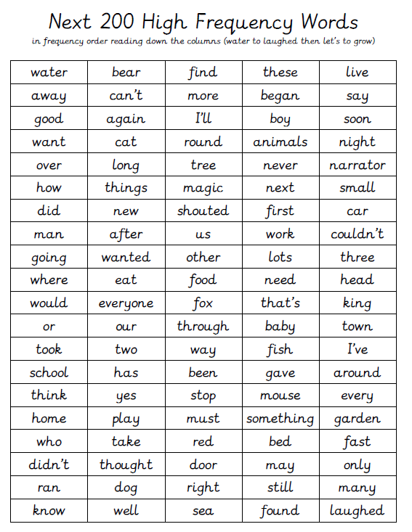 | Revise your spellings from the first 300 high frequency words!
Well done for a fantastic half term in Year 3. Miss Carter and Miss Lawrence are extremely proud of you all for your hard work and dedication! We look forward to welcoming you back to school on Tuesday 2nd June, ready for our Summer 2 term!


