Year 5 Home Learning (Autumn 1)
Resources
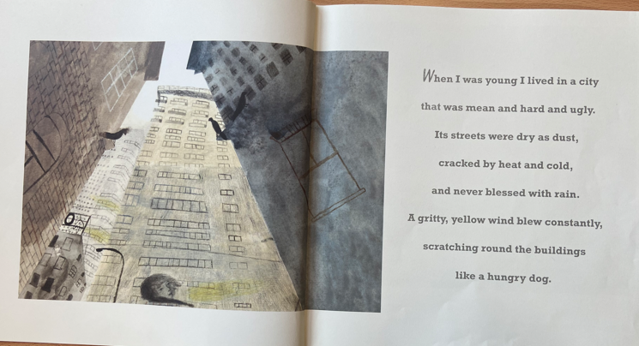
Week 1 – English – The Promise

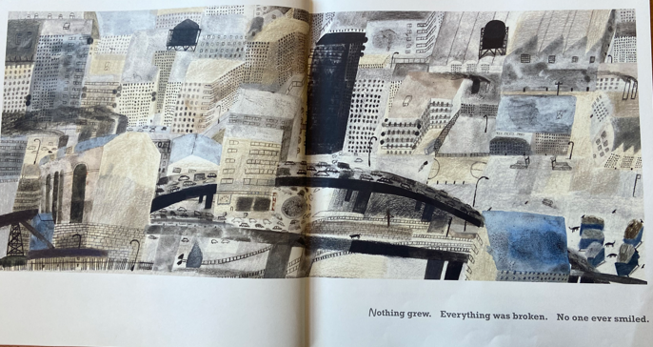

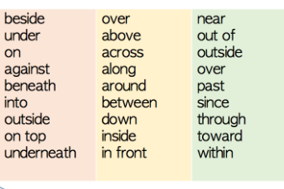
Preposition word bank
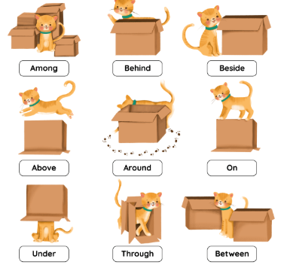

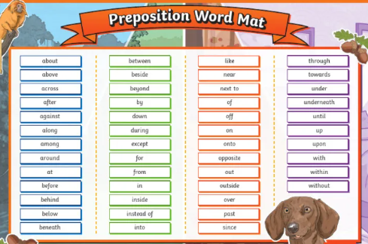

Week 1 – Maths – BBC bite size link
Please go to google and type in BBC Bitesize Year 4 Place Value
https://www.bbc.co.uk/bitesize/topics/zh4skhv/articles/zhpq7nb#zn7dfdm

Week 1 – Science - Websites for Researching Planets
Please go to google and type this in:
Planets of our Solar System - BBC Bitesize
Week 1 – History – Research websites for the Ancient Greeks
Please go to google and type this in:
Ancient Greece - Year 5 History - BBC Bitesize
Week 4 – English – Cloud Tea Monkeys


