Year 6 Home Learning (Autumn 2)
Resources
Week 1 Resources

Art

Week 1 Resources
Art

Week 2 Resources

English

The Mysterious Footprints
Early one morning, Sophie was walking her dog, Max, along the edge of the forest near her home. The ground was covered in a thin layer of frost, and the air smelled crisp and cold. As Max sniffed around, Sophie noticed a line of large footprints leading into the trees. They weren’t human—each print was wider and deeper than her hand, with long claw marks at the front.
Curious, Sophie followed the trail for a few metres until it stopped suddenly beside a fallen log. She looked around but saw nothing unusual. Just as she turned to go back, she heard a rustle behind her. Max barked loudly, and a rabbit darted out from under the log, disappearing into the forest. Sophie laughed at herself for being frightened—but when she glanced back one last time, she thought she saw a shadow move deeper among the trees.
Questions
- Literal: Where was Sophie walking when she found the footprints?
- Vocabulary: What does the word frost mean in the text?
- Inferential: Why did Sophie laugh after the rabbit ran away?
- Interpretive: What might the “shadow” at the end of the story suggest?
- Creative: Imagine you were Sophie. What would you do next, and why?

Week 2 Resources

English

The Mysterious Footprints
Early one morning, Sophie was walking her dog, Max, along the edge of the forest near her home. The ground was covered in a thin layer of frost, and the air smelled crisp and cold. As Max sniffed around, Sophie noticed a line of large footprints leading into the trees. They weren’t human—each print was wider and deeper than her hand, with long claw marks at the front.
Curious, Sophie followed the trail for a few metres until it stopped suddenly beside a fallen log. She looked around but saw nothing unusual. Just as she turned to go back, she heard a rustle behind her. Max barked loudly, and a rabbit darted out from under the log, disappearing into the forest. Sophie laughed at herself for being frightened—but when she glanced back one last time, she thought she saw a shadow move deeper among the trees.
Questions
- Literal: Where was Sophie walking when she found the footprints?
- Vocabulary: What does the word frost mean in the text?
- Inferential: Why did Sophie laugh after the rabbit ran away?
- Interpretive: What might the “shadow” at the end of the story suggest?
- Creative: Imagine you were Sophie. What would you do next, and why?

Week 4 Resources

English - The House on Hollow Hill
Everyone in the village said the old house on Hollow Hill was haunted. Its windows were cracked, its garden was overgrown, and strange lights were often seen flickering inside at night. Most people crossed the street rather than walk past it.
One afternoon, Leo and his best friend Mia dared each other to take a closer look. They crept up the front path, their shoes crunching on the gravel. The front door was slightly open, creaking gently in the wind. Leo pushed it wider, and a musty smell drifted out. Dust floated in the sunlight like tiny ghosts.
Suddenly, there was a loud bang from upstairs. Mia gasped, and Leo’s heart raced. They froze for a moment—then ran all the way back down the hill, laughing nervously. Later, when they told their friends what happened, no one believed them. But that night, from his bedroom window, Leo thought he saw a light shining again in one of the windows on Hollow Hill.
Questions
- Literal: What did people in the village say about the house on Hollow Hill?
- Vocabulary: What does the word musty most likely mean in the story?
a) Clean and fresh b) Old and slightly unpleasant
c) Sweet and flowery d) Sharp and spicy
- Inferential: Why did Leo and Mia run away from the house?
- Interpretive: What might the light in the window at the end of the story suggest?
- Creative: Imagine you were Leo or Mia. Would you go back to the house? Explain why or why not.

Art


Week 5
- _______ This early fish lived fully in water and breathed using gills. Some fish developed strong fins to help them move through shallow water.
- ______ These early amphibians had legs but newly developed lungs allowing them to breathe air and spend time on land.
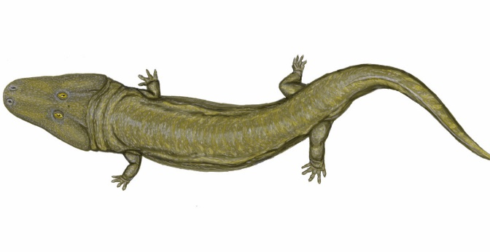
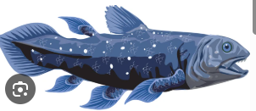
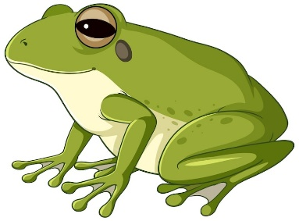
- ______ This modern amphibian spends part of its life in water and part on land — a key feature of amphibians. It has fully developed lungs and stronger leg muscles.
A
B
C

Week 5
- _______ This early fish lived fully in water and breathed using gills. Some fish developed strong fins to help them move through shallow water.
- ______ These early amphibians had legs but newly developed lungs allowing them to breathe air and spend time on land.
- ______ This modern amphibian spends part of its life in water and part on land — a key feature of amphibians. It has fully developed lungs and stronger leg muscles.
A
B
C

Week 6 Resources
English - Charles Darwin’s Great Discovery
Charles Darwin was a British scientist who changed the way people understood the natural world. In 1831, he set sail on a ship called The Beagle to study plants, animals, and rocks from around the world. One of the most important stops on his journey was the Galápagos Islands, a group of islands off the coast of South America.
While exploring, Darwin noticed that the animals on each island were slightly different from those on other islands. For example, the finches—small birds with strong beaks—had different shaped beaks depending on what kind of food they ate. This made Darwin wonder how species change over time to survive in their environments.
After many years of studying and thinking, Darwin wrote a famous book called On the Origin of Species, published in 1859. His ideas about evolution and natural selection helped explain how living things adapt and change across generations. Today, his discoveries still influence science and the way we understand life on Earth.
Questions
- Literal: What was the name of the ship Charles Darwin travelled on?
- Vocabulary: What does the word adapt mean in the text?
a) To stay exactly the same
b) To change in order to survive
c) To travel across oceans
d) To study animals carefully
- Inferential: Why were the finches on the Galápagos Islands important to Darwin’s ideas?
- Interpretive: How did Darwin’s discoveries change the way people understood life?
- Creative: Imagine you were a young scientist on The Beagle. What kind of discovery would you hope to make, and why?
Week 6 Resources
English - Charles Darwin’s Great Discovery
Charles Darwin was a British scientist who changed the way people understood the natural world. In 1831, he set sail on a ship called The Beagle to study plants, animals, and rocks from around the world. One of the most important stops on his journey was the Galápagos Islands, a group of islands off the coast of South America.
While exploring, Darwin noticed that the animals on each island were slightly different from those on other islands. For example, the finches—small birds with strong beaks—had different shaped beaks depending on what kind of food they ate. This made Darwin wonder how species change over time to survive in their environments.
After many years of studying and thinking, Darwin wrote a famous book called On the Origin of Species, published in 1859. His ideas about evolution and natural selection helped explain how living things adapt and change across generations. Today, his discoveries still influence science and the way we understand life on Earth.
Questions
- Literal: What was the name of the ship Charles Darwin travelled on?
- Vocabulary: What does the word adapt mean in the text?
a) To stay exactly the same
b) To change in order to survive
c) To travel across oceans
d) To study animals carefully
- Inferential: Why were the finches on the Galápagos Islands important to Darwin’s ideas?
- Interpretive: How did Darwin’s discoveries change the way people understood life?
- Creative: Imagine you were a young scientist on The Beagle. What kind of discovery would you hope to make, and why?
Week 7 Resources
English
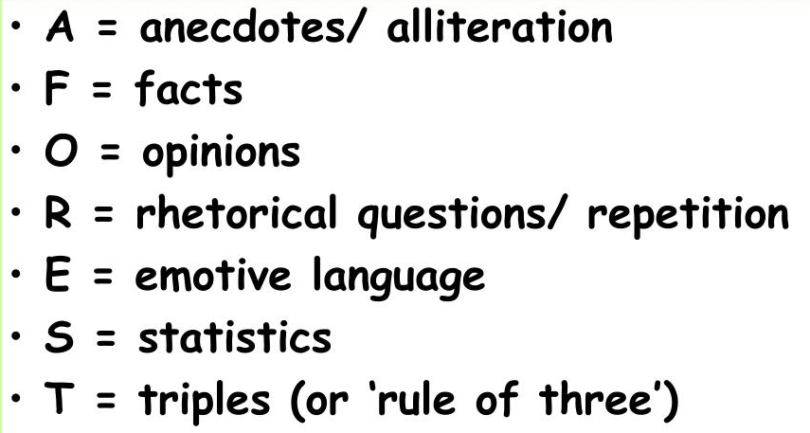

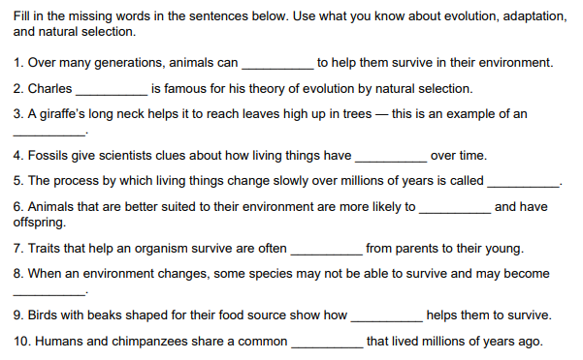

Word bank:
extinct, evolution, survive, ancestor, Darwin, adapt, changed, inherited, adaptation, ancestor

