Year 5 Home Learning (Autumn 2) Resources
English
Example Diary Starter (Cloud Tea Monkeys)
Today, the mountains looked like a sea of emerald waves. I felt small beneath the endless sky, mum has been sick for a long while now…

Example Acrostic Poem (Where do the Poppies Grow?)
P – People remembered
O – Our heroes brave
P – Poppies in the field
P – Peace we hope for
Y – Yesterday’s sacrifices
Example Free Verse Poem (Where do the Poppies Grow?)

The ground is cold beneath me,
and the air smells of smoke.
I hear shouting far away,
then silence — just the wind.

I miss my home,
the garden,
the sound of my dog barking.
Here, everything feels grey.

But I hold on to hope,
that one day soon,
I’ll see the sun rise
over peaceful fields again.

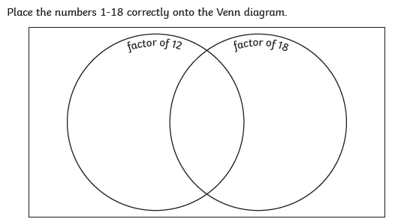
Maths

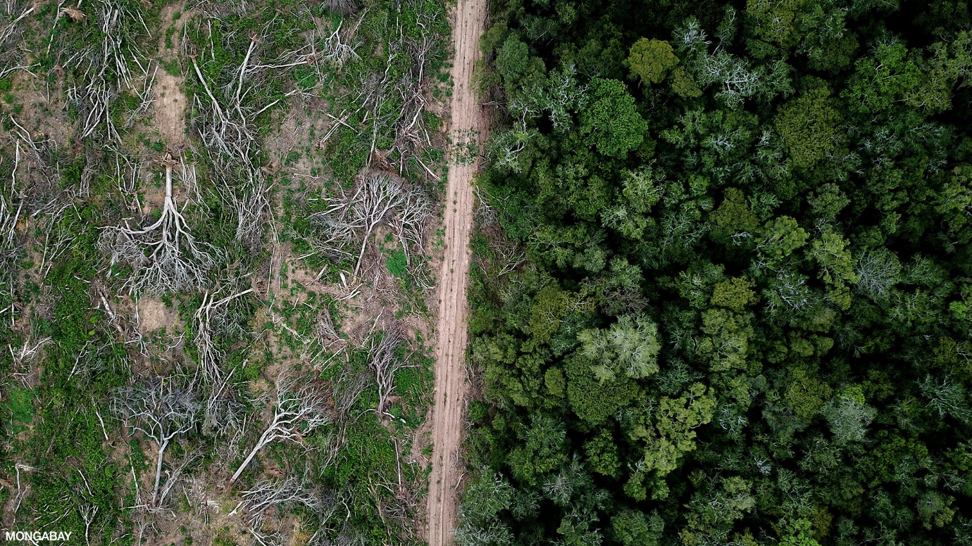
Geography

Science – Parachute Plan


