Year 4 Home Learning (Autumn 2)
Resources

English – Week 2
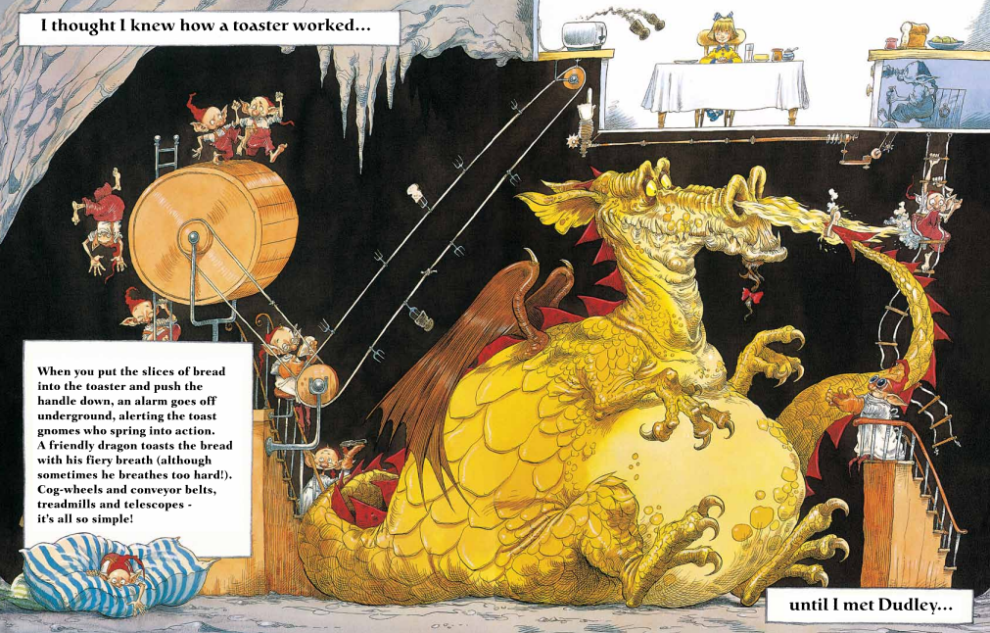
English – Week 3
Fronted adverbials are words, phrases, or clauses placed at the beginning of a sentence for detail about time, place, or manner, followed by a comma. For example, "Calmly, the family sat together" or "As the clock struck ten, Zaynab served breakfast".

English – Week 4
To summarise a story, you need to read it carefully to identify the main characters, setting, plot, and key events, including the beginning, middle, and end. Then, retell the story in your own words, focusing on the most important details.

English – Week 5
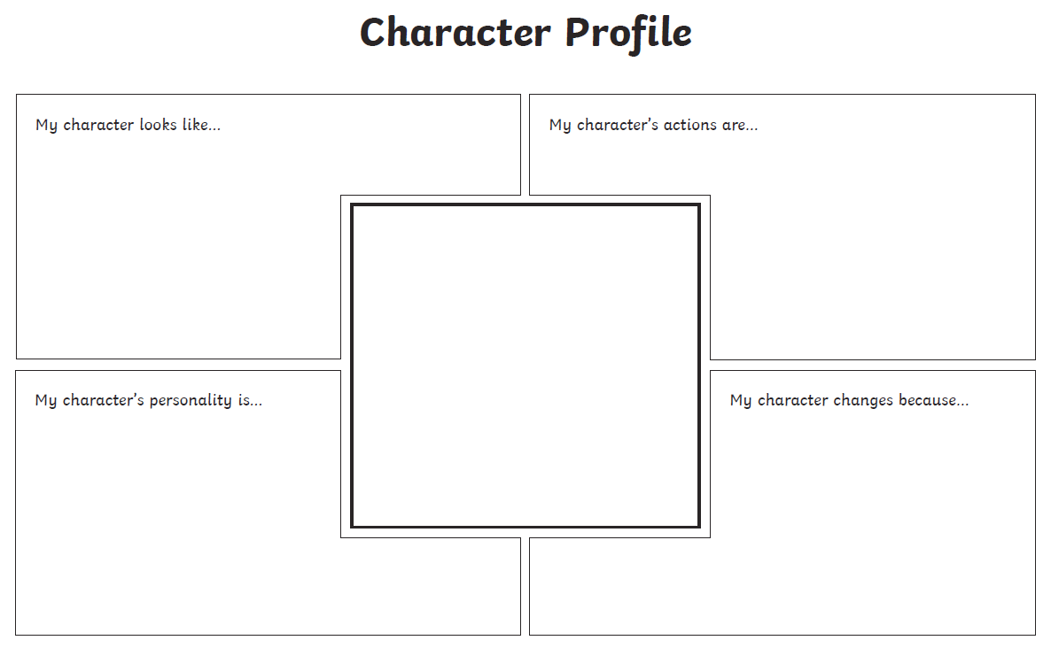
English – Week 6



Week 1: Geography


