Year 3 Home Learning (Autumn 2)
Resources
Week 1
Maths: column method example
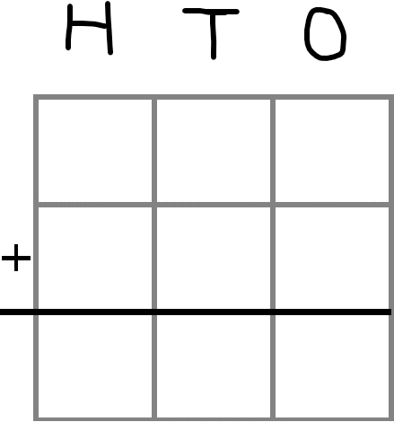
Geography
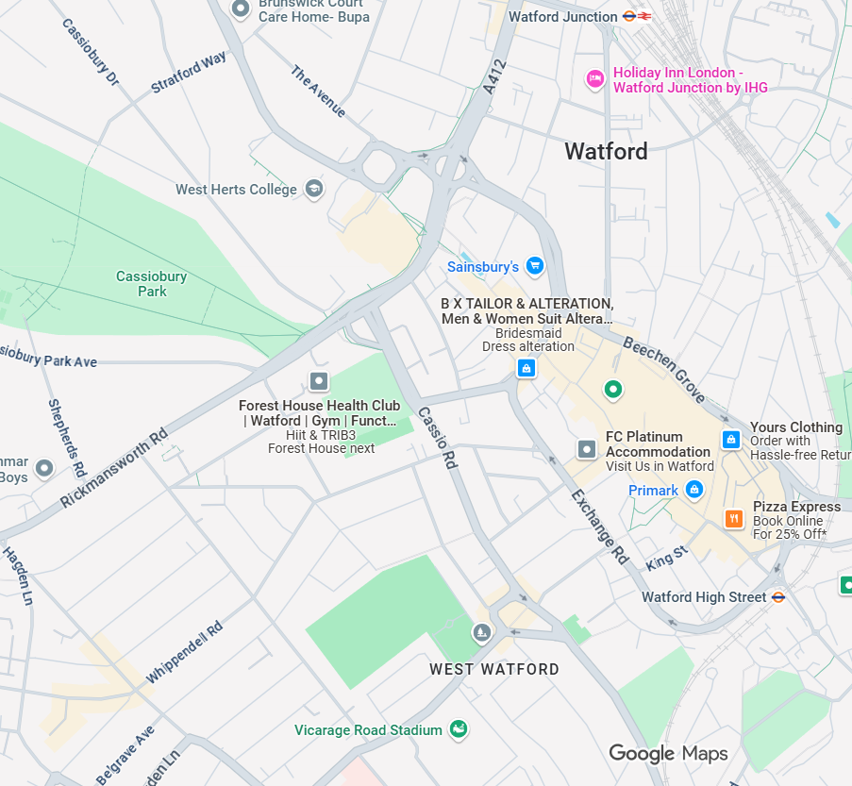
Week 2
Maths: Column method example
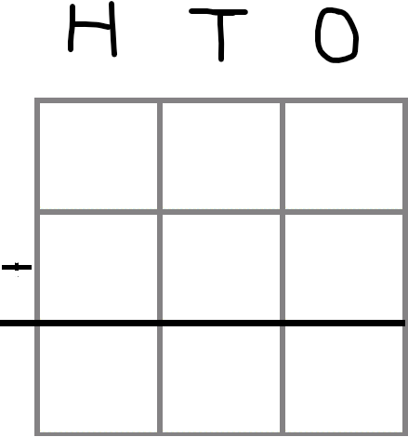
Geography
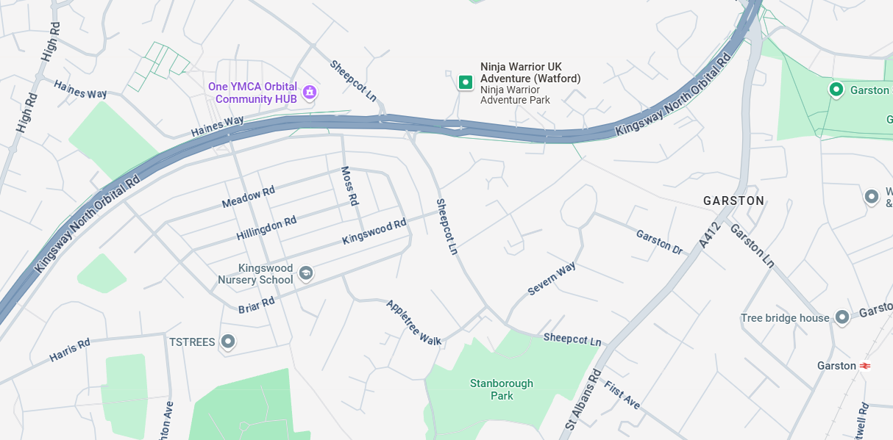
RE- Christmas symbols

Week 3
English
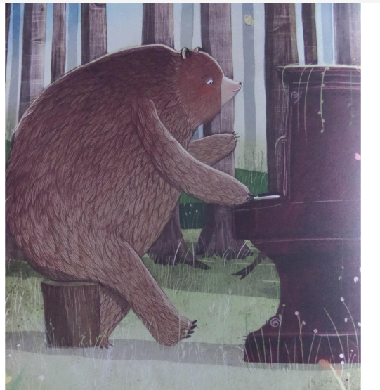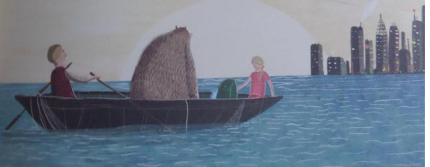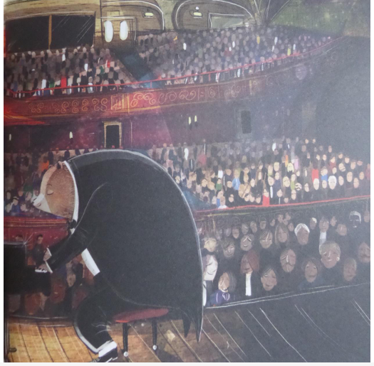

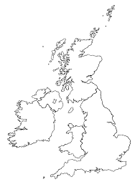
Geography-

RE
Jesus came to earth to defeat Satan and his work (1 John 3:8)
God sent Jesus to earth to be the only Mediator between God and mankind, the one and only "way, truth, and life" (1 Timothy 2:5; John 14:6)
He came to be the perfect, sacrificed "Passover Lamb" for our sins (1 Corinthians 5:7).
Week 4- Geography
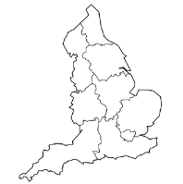

Week 5
Angles: Challenge:
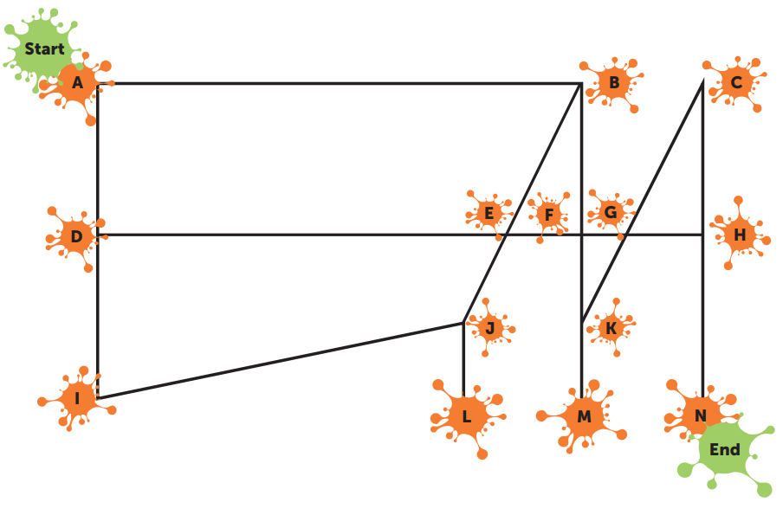
Acute, obtuse or right angles?
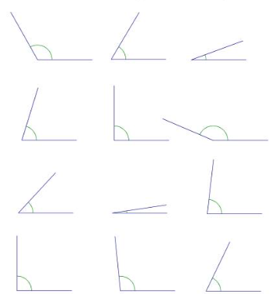

Week 6:
Bar charts


