Year 5 Home Learning (Spring 1)
 | Week 1 | Week 2 | Week 3 | Week 4 | Week 5
English | The World of the Unknown –  Create a Mythical Creature Report  Design a mythical creature, then write a short encyclopedia-style report about it. Imagine your creature has just been discovered, and you are the expert describing it to the world.  Your report should include:  1. Introduction  Write a paragraph introducing your creature. Include its name, where it was discovered, and why it is considered unusual or important.  2. Physical Description  Describe your creature in detail. Include:  Size  Colour  Body shape  Any unique features (wings, scales, glowing eyes, extra limbs, etc.)  3. Habitat & Lifestyle  Explain:  Where it lives  How it survives in its habitat  What it eats  How it interacts with other creatures  4. Abilities & Powers  Describe its magical or special abilities.  Explain how and when it uses them.  5. Personality & Behaviour  Is it dangerous, friendly, protective, shy, or playful?  Give examples of its behaviour.  6. Fun Fact Section (Optional)  Add at least one surprising or interesting fact about your creature. | Fantastically Great Women who Changed the World  Step 1: Choose a Person  Pick one inspirational woman from the list below (or another you know):  - Marie Curie – scientist who discovered radium and polonium  - Malala Yousafzai – activist for girls’ education  - Ada Lovelace – first computer programmer  - Rosa Parks – civil rights activist  - Jane Goodall – primatologist and conservationist  Step 2: Find Information  Use child-friendly websites like:  https://www.ducksters.com/biography/  https://kids.nationalgeographic.com/  Step 3: Read and Take Notes  While reading, write down key facts. You can use this table to help:  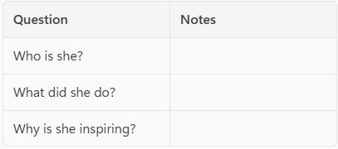  Step 4: Be Creative  Draw a picture of her or something she achieved. You can use pencils, crayons, or even make a collage!  Challenge  -Write 3 interesting facts about her life.  -Add the year she was born and (if applicable) when she died.  -Explain how her work still matters today. | Fantastically Great Women who Changed the World  Step 1: Choose a Woman  Pick one inspirational woman to research (from last week’s reading or your own choice).  Using these sentence starters, write full sentences about your chosen woman.  - She was born in…  - When she was a child, she…  - As she grew older, she…  - She started her work by…  - One important thing she did was…  - She is remembered for…  - People admire her because…  - She also…  - Later in her life, she…  - She received…  - Her biggest achievement was…  - She changed the world by…  - She became known as…  Example Paragraph:  Marie Curie was born in Warsaw, Poland, in 1867. When she was a child, she loved learning and worked hard at school. As she grew older, she moved to Paris to study science. She started her work by researching different elements in a laboratory. One important thing she did was discover two new elements called radium and polonium. She is remembered for her amazing discoveries in chemistry and physics. People admire her because she never gave up, even when life was difficult. She also became the first woman to win a Nobel Prize. Later in her life, she continued her research and helped develop treatments for cancer. Her biggest achievement was winning two Nobel Prizes in different sciences. She changed the world by showing how science can save lives. She became known as one of the greatest scientists in history. | The Water Tower  Activity 1: Front Cover Investigation  Predicting and inferring from visual clues  Look carefully at the front cover of The Watertower.  Questions to answer:  -What do you notice first?  -What colours and shapes stand out?  -How does the cover make you feel?  -What do you think the story might be about?  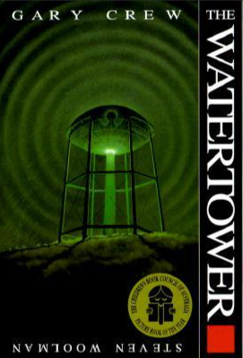  Challenge: Write a short paragraph predicting what will happen in the story based on the cover. Use phrases like:  I think the story will be about… because…  The cover makes me feel… which suggests… | The Water Tower  Activity 2: Setting Description – The Watertower  Using descriptive language  Look at the pictures and think about the Watertower.  OUTSIDE  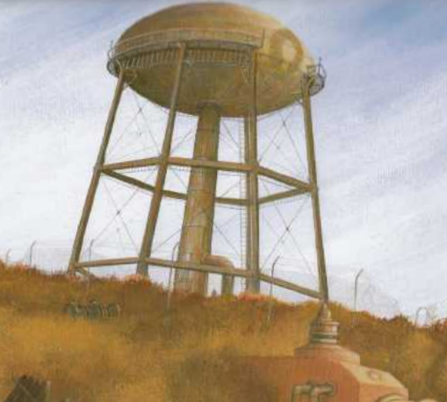  INSIDE  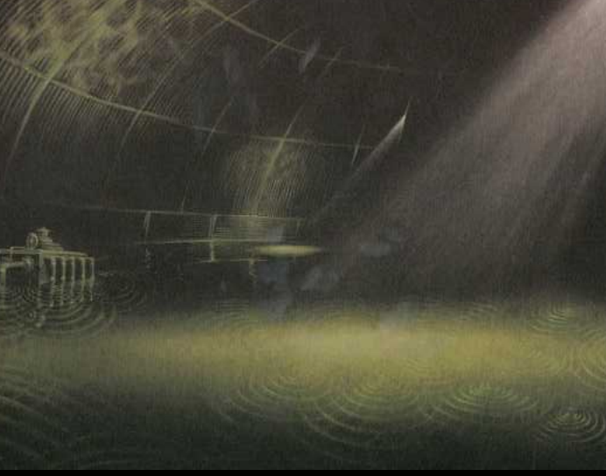  Questions to answer:  -What does it look like?  -What words describe its size, shape, and colour?  -How does it make the town seem?  Write a descriptive paragraph about the Watertower. Use:  Adjectives (dark, rusty, towering)  Similes (like a giant standing over the town)  Sentence starters:  The watertower stands…  Its walls are…  It looks as if…
Maths | Revise your understanding of multiplication, then answer these word problems. Remember to read and underline the key information.  https://www.bbc.co.uk/bitesize/topics/z36tyrd/articles/zvg4bqt  https://www.bbc.co.uk/bitesize/topics/z36tyrd/articles/z8fyhcw  Sarah buys 3 pencils for 45p each. How much does she spend in total?  A cake costs £12. John buys 3 cakes. How much does he pay?  There are 45 sweets. If 9 are eaten, how many are left?  A box contains 56 chocolates. If 8 go into each bag, how many bags can you fill?  Lily buys 5 juice cartons at £2.50 each and pays £1.50 delivery. How much does she spend in total?  A bus has 40 seats. 28 are full. How many are empty? | Revise your understanding of fractions, then have a go at these mixed fraction questions.  https://www.bbc.co.uk/bitesize/topics/zhdwxnb  See questions on attached resource sheet. | Revise your understanding of converting units, then answer the following questions below. Use the key fact box on your resource sheet to help you.  https://www.bbc.co.uk/bitesize/topics/zt9k7ty  -Convert 500 mL of milk into litres.  -Convert 2.5 kg of flour into grams.  -Convert 350 cm of ribbon into metres.  -Convert 4.2 L of juice into mL.  -Convert 1.8 m of rope into cm.  -A bottle has 750 mL of juice. How many litres is this?  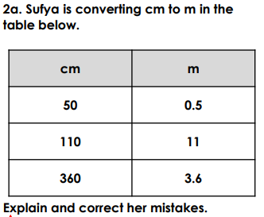 | Revise your understanding of perimeter. Then calculate the following:  https://www.bbc.co.uk/bitesize/articles/zsr4k7h  Find the area of a rectangle-shaped notebook that is 6 cm long and 4 cm wide.  Find the area of a square sticky note with side 5 cm.  A classroom rug is a rectangle 10 m long and 3 m wide. Find the area.  A square garden has side 7 m. What is its area?  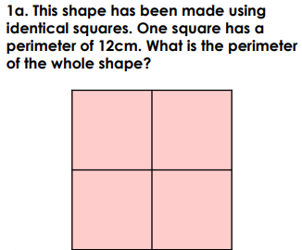 | Revise your understanding of perimeter. Then calculate the following:  https://www.bbc.co.uk/bitesize/articles/zsr4k7h  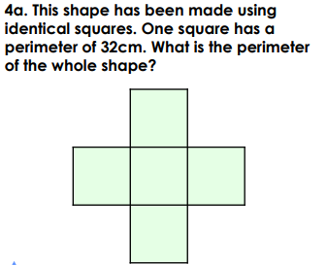  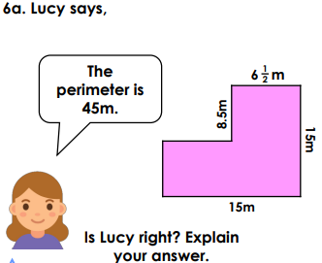
Science | What are the different properties of materials?  Look around your home and make a list of 10 different materials (wood, metal, plastic, fabric, glass, etc.).  Challenge: Write three properties for each (e.g., hard, flexible, shiny, waterproof).  Outcome: Table or chart showing materials and their properties. | Do I understand what a conductor is and how this works?  Look at common materials at home (metal spoon, plastic ruler, wooden spoon).  Challenge: Decide which materials let electricity pass through (conductors) and which do not (insulators).  Make a table with two columns: Conductors / Insulators. | Can I compare and test different materials to understand their suitability for use?  Choose 3–4 materials you can find at home, such as:  Paper  Tin foil  Fabric  Plastic bag  Cardboard  Step 1: Pick your test  Choose one thing to test:  Strength – Which material can hold the most weight?  Flexibility – Which one bends without breaking?  Waterproofing – Which one keeps water out?  Step 2: Test your materials  Test each material in the same way.  For example:  For strength, put small coins or objects on top until it breaks.  For flexibility, try bending or twisting it.  For waterproofing, drop some water on it and watch what happens.  Step 3: Record your results  Make a simple table to record your results, see resource sheet for example. | Do I understand what dissolving is and which materials will dissolve?  What dissolves in water?  What you need:  A cup or glass of water  Small amounts of: sugar, salt, sand, oil  Spoon for stirring  Home Learning book to record results  Step 1: Test each material  Take a spoonful of one material and put it in water.  Stir for a few seconds.  Watch carefully: does it disappear (dissolve) or stay the same?  Repeat for all materials.  Step 2: Record your results  Make a simple table like this:  Material Dissolves? (Yes/No) | Can I identify what a solute, solution and solvent are?  What you need:  A glass of water  Sugar (or salt/cocoa powder)  Spoon for stirring  Step 1: Make a solution  Pour some water into a glass (this is your solvent).  Add a spoonful of sugar (this is your solute).  Stir until it disappears.  Now you have a solution!  Step 2: Identify the parts  Solute: The substance that dissolves (sugar, salt, or cocoa).  Solvent: The liquid that does the dissolving (water).  Solution: The mixture you get after dissolving.  Draw a labelled diagram of what you did in your books.
RE | Do I understand that there are different worldviews and beliefs?  Understanding Different Beliefs  Activity: Draw a picture showing how your family or community practices their beliefs, and how Sikhs show their beliefs.  Prompt questions:  What do you or your family do that shows your beliefs?  What do Sikhs do to show their beliefs? (Think about prayer, going to a Gurdwara, or helping others.)  Key vocabulary: belief, Sikh, Gurdwara, equality | What do Sikhs believe?  Match the Sikh belief to its meaning, then write a short sentence explaining why it is important.  God is in everything  Duty to serve others (sewa)  Treat everyone equally  Share what you have  Earn your living honestly  Meanings:  a) Help other people and give your time or energy for them.  b) Treat all people the same, no matter who they are.  c) Work honestly and don’t cheat.  d) Share your food, money, or toys with others.  e) See God everywhere, in all living things and nature.  Which belief do you think is most important? Why? | How do Sikhs show their faith?  Activity: Complete the sentences using the words below: Gurdwara, Golden Temple, Khalsa, 5 K’s, pilgrimage  A place where Sikhs worship is called a __________.  Some Sikhs go on a special visit called a __________ to the __________ in Amritsar.  The __________ are five special items that remind Sikhs of their faith.  Extension question: Why do you think Sikhs might want to visit the Golden Temple?  Key vocabulary: Gurdwara, Golden Temple, Khalsa, pilgrimage, 5 K’s | Can I understand the perspective of a person that might have a different worldview to my own?  Activity: Write 3 short paragraphs about how a Sikh might feel in these situations. Use the prompts below.  Visiting the Golden Temple – what would they see, hear, or feel?  Taking part in Langar – how does it feel to sit and eat with everyone?  Doing Sewa – how might it feel to help someone else without expecting anything back?  Prompt sentence starters:  “I think a Sikh might feel __________ because __________.”  Key vocabulary: Golden Temple, Langar, sewa, equality, community | Who was Guru Nanak and why was he important?  Write 2–3 sentences explaining why Guru Nanak is important. Then, draw a picture showing one of his teachings in action.  Prompt questions:  What did Guru Nanak teach about how people should be treated?  Why do Sikhs still follow his teachings today?  Key vocabulary: Guru Nanak, equality, Sikh, teaching
History | Where did the Maya live?  Create a simple labelled map showing where the Maya lived.  What to include:  Label Mexico, Guatemala, Belize, Honduras and El Salvador  Shade the Yucatán Peninsula  Add a title: “The Maya Region”  Support:  The Maya lived in Central America, mostly in rainforests and lowlands.  Use an atlas or Google Maps to help you see the shapes of the countries. | What were the significant events in Mayan history?  Research and create a timeline of at least 5 important events in Maya history.  What to include:  When the first Maya villages appeared  When major cities (e.g., Tikal, Palenque) were built  When writing and calendars developed  When the civilisation declined | What were the Maya city-states like?  Draw or sketch a Maya city-state and label its features.  Include labels such as:  Temple–pyramid  Palace  Ball court  Houses made from wood/mud  Market area  Support:  Each Maya city-state had its own ruler and acted like its own small kingdom, similar to lots of little countries. | What did the Maya invent?  Make a poster showing 3–5 Maya inventions.  Possible inventions to include:  Chocolate  The 365-day calendar  Their writing system (hieroglyphs)  The number zero  Terraced farming  Support:  Use headings, small pictures and speech bubbles like:  “Did you know? The Maya were one of the first civilisations to use zero!” | What happened to the Maya city-states?  Write a short explanation (4–6 sentences) of why many Maya cities were abandoned.  Support:  Start with this sentence frame:  “Many Maya city-states were abandoned because…”  You may include:  Droughts  War between city-states  Lack of food  People moving to safer or better areas  You don’t need one exact reason. Historians think several problems happened at once.

