Year 4 Learning (Spring 1)

 | Week 1  5.1.26 | Week 2  12.1.26 | Week 3  19.1.26 | Week 4  26.1.26 | Week 5  2.2.26
English | Write a book review for a book of your choice.  See Resources - English Week 1 | Write a paragraph to describe a scene from Leon and the place between.  See Resources - English Week 2  What did Leon see?  What did he hear?  What did he touch?  How did he feel? | Draw and write a paragraph to describe a magical setting.  See Resources - English Week 3  Include:  Five senses e.g. The rhythmic clicking of a thousand tiny clocks.  Personification e.g. The gnarled branches reached out like witches' fingers.  Fronted Adverbials e.g. Beyond the shimmering waterfall... | Research a travel destination that you have visited.  Write interesting facts about your chosen destination.  Include:  Things to do  Places to visit  See Resources - English Week 4 | Design a travel brochure for the destination you researched last week.  See Resources - English Week 5
Maths | Practice your Multiplication tables on this link:  https://urbrainy.com/mtc  https://play.ttrockstars.com/auth/school/student/34413  Attached question: Week 1  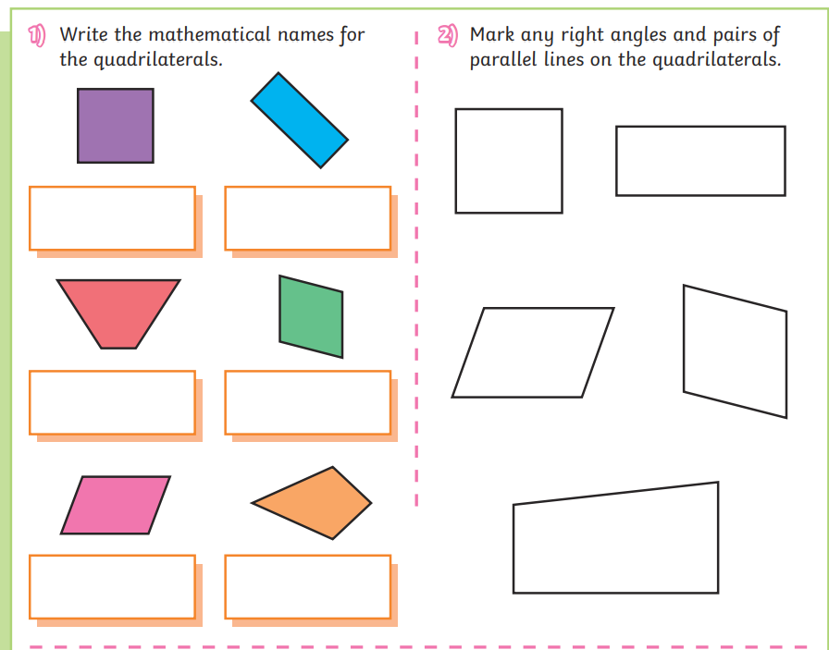 | Practice your Multiplication tables on this link:  https://urbrainy.com/mtc  https://play.ttrockstars.com/auth/school/student/34413  Attached question:  Week 2  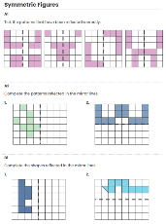 | Practice your Multiplication tables on this link:  https://urbrainy.com/mtc  https://play.ttrockstars.com/auth/school/student/34413  Multiplication facts for 3, 4, 5, 6, 7 and 9  3 x 6 =  3 x 9 =  4 x 4 =  4 x 8 =  5 x 7 =  5 x 12 =  6 x 6 =  6 x 9 =  7 x 7 =  7 x 9 =  9 x 9 =  9 x 12 = | Practice your Multiplication tables on this link:  https://urbrainy.com/mtc  https://play.ttrockstars.com/auth/school/student/34413  Attached question:  Week 4  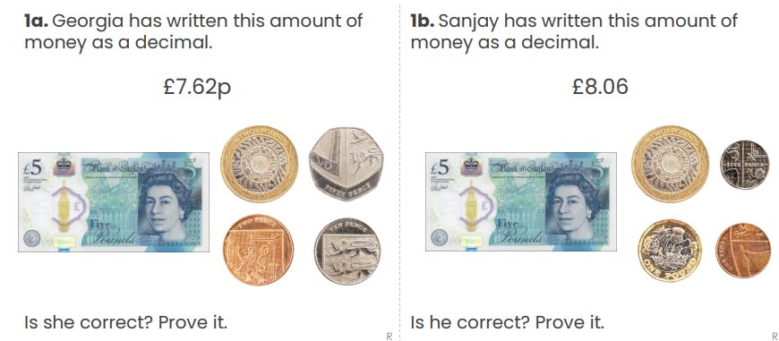 | Practice your Multiplication tables on this link:  https://urbrainy.com/mt  https://play.ttrockstars.com/auth/school/student/34413  Attached question:  Week 5  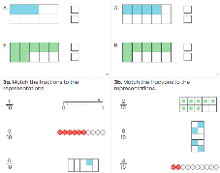
Science | Answer the questions below about our new topic Sound.  How is sound created?  How does sound travel?  How is sound received by the human ear?  See Resources - Science Week 1-5 | Which medium does sound travel fastest in solid, liquid or gas? Explain why? | What is volume of sound? What causes different volumes of sounds?  See Resources - Science Week 1-5 | Create a musical instrument which can produce different pitches.  See Resources - Science Week 4 | Design a poster about all your learning for our topic sound. Include labelled diagrams.  See Resources - Science Week 1-5
History | When the Vikings invaded England, Alfred led his army to fight and defend his kingdom.  Alfred the Great  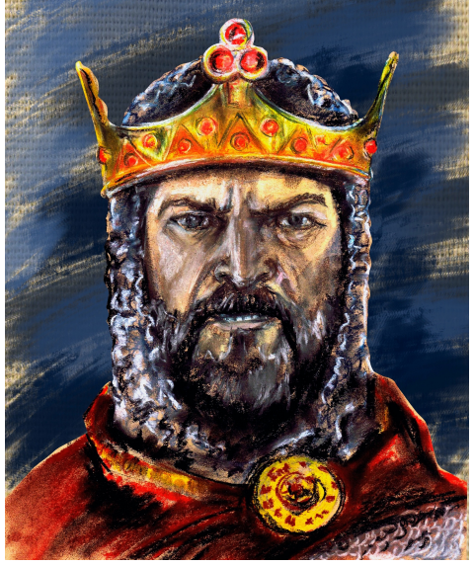  Design and label an armour for his army. Your design needs to include: helmet, nose guard, boots, shield and sword. | Where did the Vikings invade and settle?  The Vikings invaded and settled in many places across Europe. They came from Scandinavia, which includes Norway, Denmark and Sweden. The Vikings settled in Britain, especially in England, where they took over places like York (called Jorvik). They also settled in Ireland, Scotland, Iceland, Greenland and parts of France known as Normandy. Vikings chose places near rivers and coasts because it helped them travel, trade and raid easily.  1.Where did the Viking come from?  2. Name the places they invaded?  3. What did these places have that helped the Viking?  4. As a Viking which country would you have settled in and why? | Write a letter to a friends about your recent trip to the British Museum.  Dear Joey,  I went to the British Museum and saw the Egyptian section. It was exciting and interesting. I saw mummies, statues and hieroglyphs. My favourite part was the mummy because it was very old. I had a great day and learned lots.  From,  Jo  Words describing what you saw:  mummies  sarcophagus (mummy case)  statues  artefacts  hieroglyphs  ancient  treasures  golden | What peace was agreed between the Anglo-Saxons and Vikings?  Comprehension:  The peace agreed between the Anglo-Saxons and the Vikings was called the Treaty of Wedmore. King Alfred the Great and the Viking leader Guthrum agreed to stop fighting. England was split into two parts, and the Viking area was called the Danelaw.  Questions:  1.What was the peace agreement called?  2.Who was the Anglo-Saxon king?  3.Who was the Viking leader?  4. What did King Alfred and Guthrum agree to do?  5. What happened to England after the treaty?  6. What was the Viking area called?  7. Why do you think splitting England helped keep peace? | Why did the Normans and the Vikings both think they had the right to the throne of England?  William of Normandy (Normans) thought he should be king because he was related to Edward and believed Edward had promised him the throne.  Harald Hardrada (Vikings) thought he should be king because he was linked to earlier Viking kings of England and believed the throne had been promised to him.  Draw William of Normandy and Harald Hardrada below.  Write one reason why each thought he should be king.
Art | Write a biography about William Morris, the artist who we will be learning about this term. | Choose one of William Morris’s floral patterns and draw it using pencil. Then colour it in.  See Art resources Week 2 | William Morris made detailed textile and wallpaper designs using a block printing method  where he would repeatedly use the same blocks to create a pattern.  You are going to practice your pattern making and drawing skills using the designs of William Morris as inspiration.  See Art resources Week 3 | This week you are going to practice drawing a symmetrical pattern inspired by William Morris’s designs.  See Art resources Week 4 | Design your own repeating pattern using inspiration from William Morris’s designs.  See Art resources Week 5

