Year 4 Home Learning ( Spring 1)
Maths Resources
Week 1:
Choose the correct name of the quadrilaterals:
kite, parallelogram, rhombus, trapezium, rectangle, square
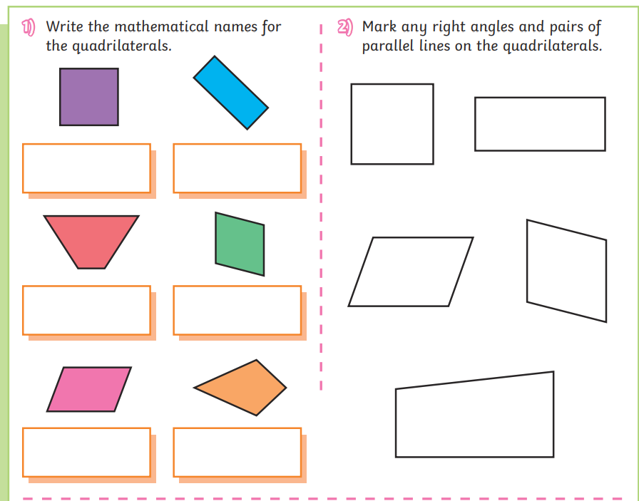

Week 2
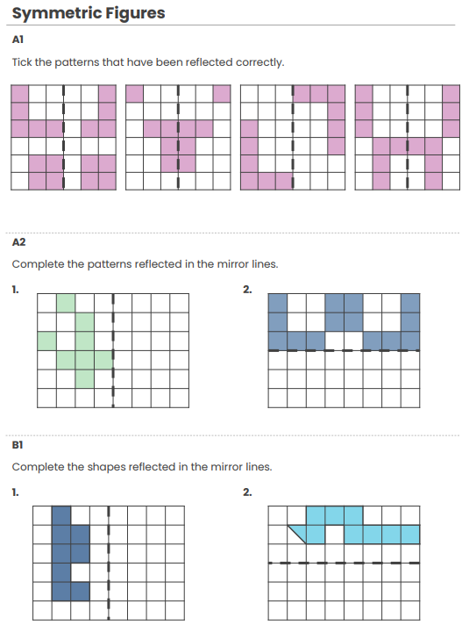
Week 4
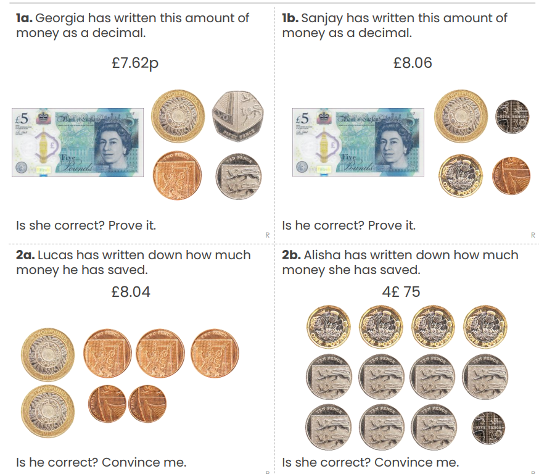
Week 5
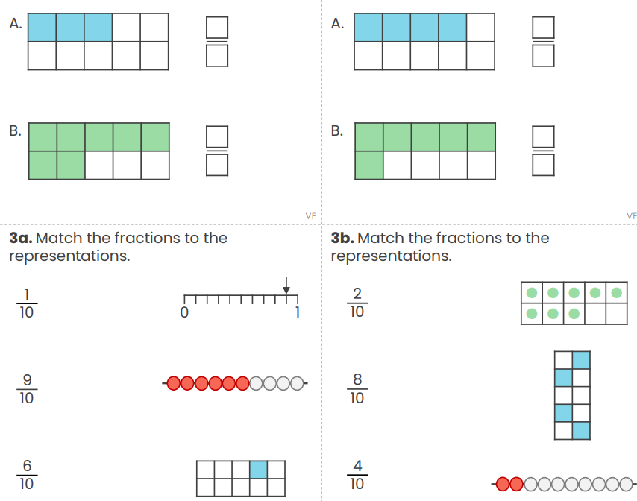

English Week 1
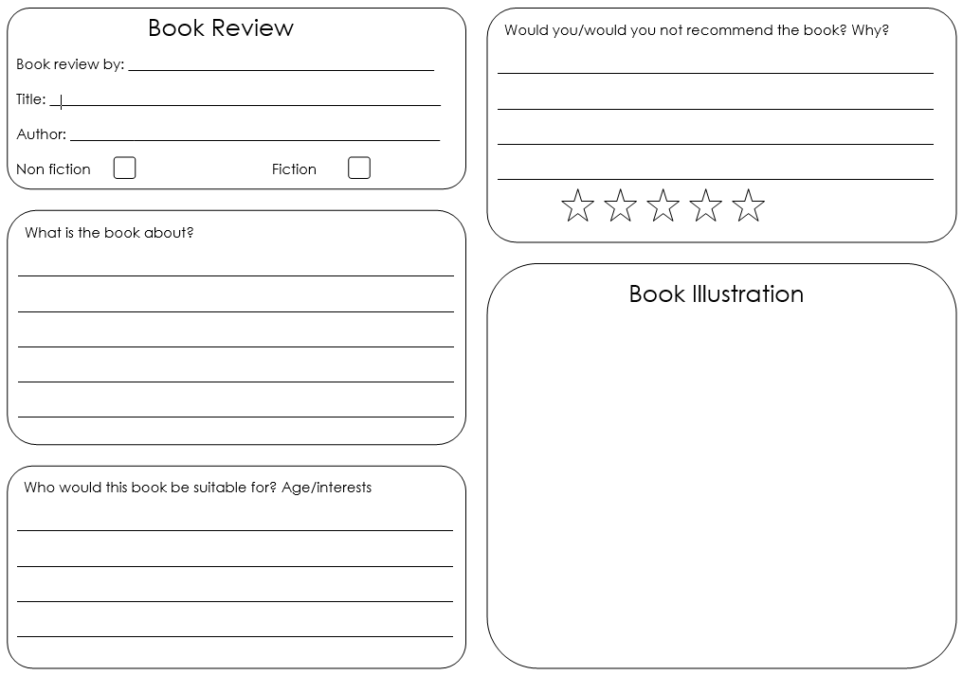

English Week 2


English Week 3


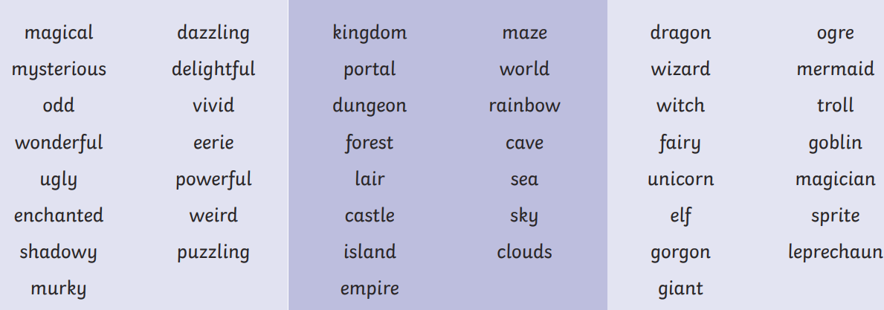

English Week 4

- The Rule of Three: Use three adjectives together to make your point stronger (e.g., "exciting, wonderful, and unbelievable").
- Rhetorical Questions: Ask a question that doesn't need an answer to make your reader think (e.g., "Who wouldn't want to see the Crown Jewels?").
- Emotive Language: Use powerful "bossy" verbs and adjectives to make the reader feel excited (e.g., magnificent, stunning, must-see).
- Personal Touch: Use "you" and "your" to speak directly to the reader.

English Week 5

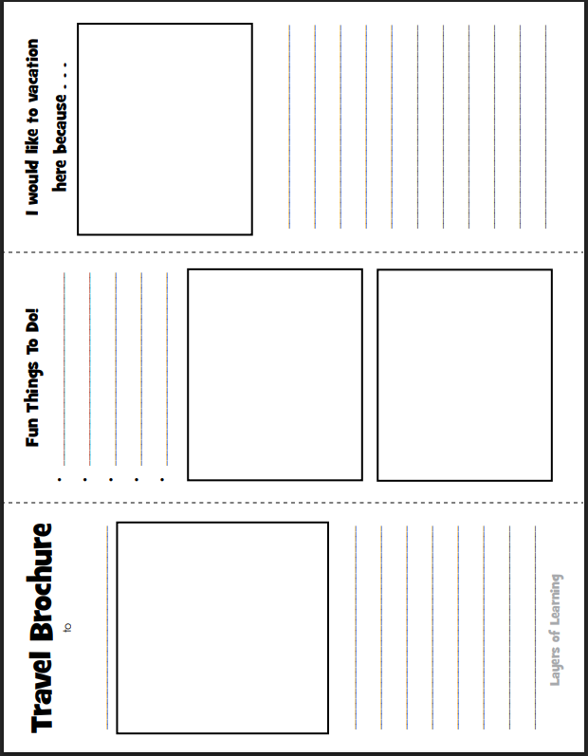
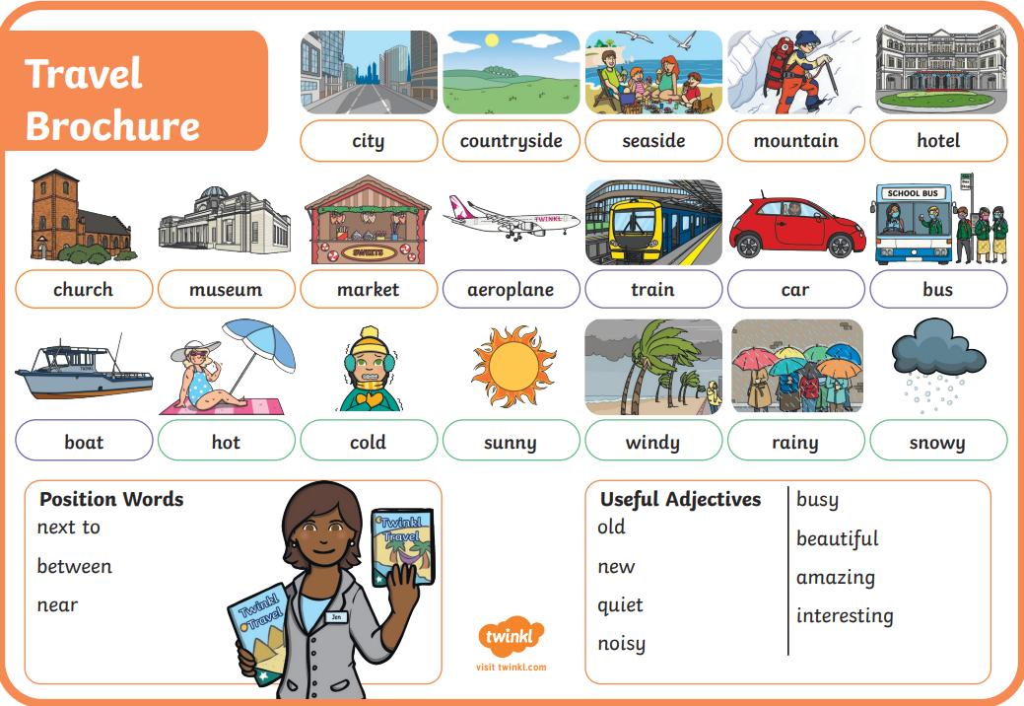
Science Week 1-5
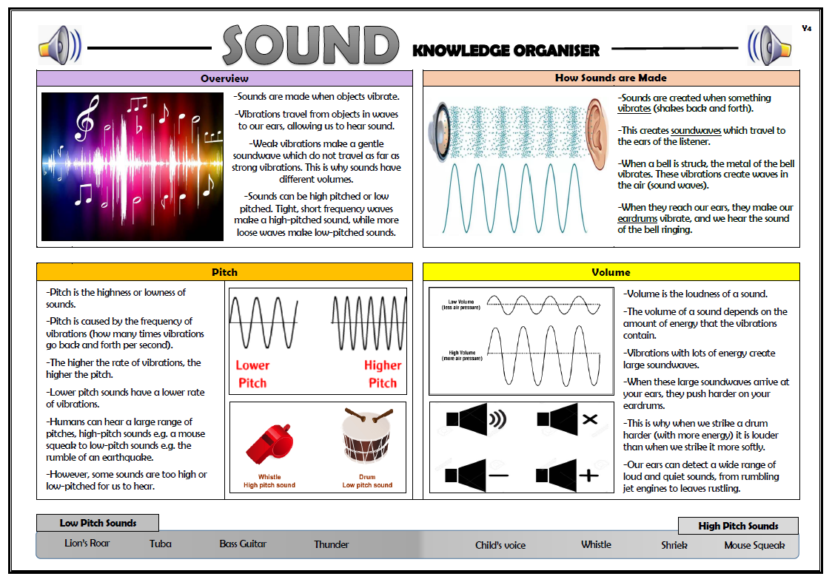
Science Week 4
Create a musical instrument which can produce different pitches.
1. Water Xylophone (Percussion)
- What you need: 5–8 identical glass jars or bottles and water.
- How to make it: Fill each jar with a different amount of water.
- How it changes pitch: Tap the side of each jar with a pencil or spoon. Which jar/bottle has the highest/lowest pitch?
2. Straw Pan Pipes (Wind)
- What you need: Plastic or paper straws, tape, and scissors.
- How to make it: Cut the straws into different lengths (e.g., the first is 15cm, the second is 13cm, etc.). Tape them together in order from longest to shortest.
- How it changes pitch: Blow across the top of the straws. Which straw produces the highest pitch and why?
3. Elastic Band Guitar (String)
- What you need: An empty tissue box or cardboard container and several elastic bands.
- How to make it: Stretch the elastic bands around the box. Use bands of different thicknesses or stretch them to different tensions.
- How it changes pitch: Pluck the bands. Which band makes the highest pitch? Why?

Art Week 2



Art Week 3



Art Week 4
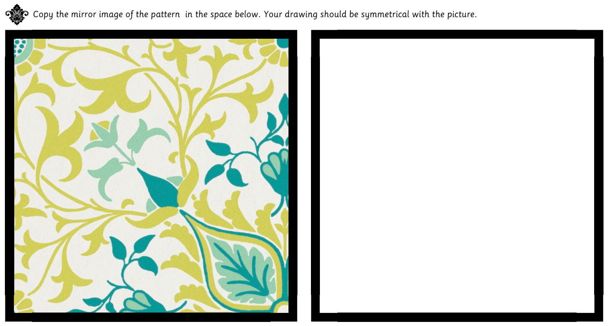

Art Week 5


