Year 6 Home Learning (Spring 1)
Resources

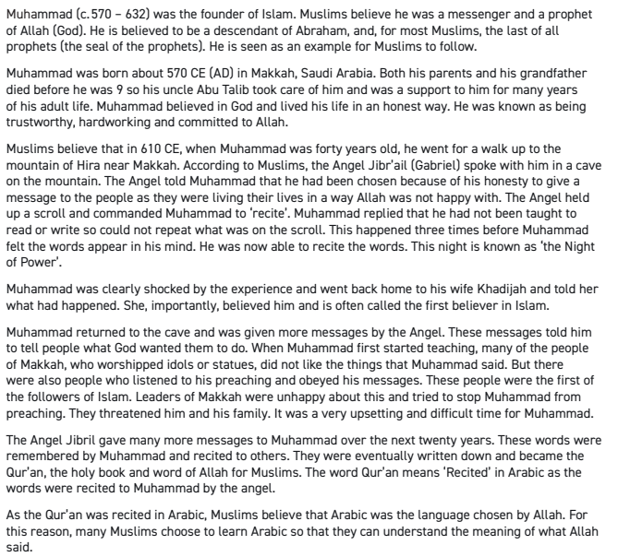
Week 2 Resources

Week 4 Resources
Artificial Intelligence, or AI, is when computers or machines are able to perform tasks that usually need human thinking. This can include understanding language, recognising pictures, solving problems, and even playing games. AI is used in many areas of our daily lives. For example, smartphones use AI to suggest words while typing, video games use AI to make characters smarter, and online platforms use AI to recommend videos or music that you might like.
AI can be very helpful, but it also comes with challenges. Some people worry that if machines become too intelligent, they might make mistakes or take over jobs that humans do. Scientists and engineers are working carefully to make AI safe and useful. They also teach AI systems to learn from data and improve over time. By understanding AI, people can use it in smart ways while avoiding problems.
- What does the word “recognising” mean in the passage?
- Why do you think AI is used in video games and online platforms?
- How might AI be used in the future to help people in their daily lives?
- Explain why scientists need to be careful when developing AI.
- What are two examples of how AI is used in daily life?
- What is one challenge mentioned in the passage about AI?
- In 1–2 sentences, summarise what AI is and why it is important.

Week 6 Resources
One sunny afternoon, Mia was walking home from school when she heard a soft whimpering sound behind a bush. Curious, she went closer and found a small, shivering puppy with muddy fur. It looked scared and hungry. Mia gently picked up the puppy and decided to take it home. She gave it some water and a piece of her sandwich. The puppy wagged its tail happily and seemed to trust her instantly.
Mia wanted to find the puppy’s owner, so she made a poster and asked her neighbours if anyone had lost a dog. After a few hours, an elderly man knocked on her door. He smiled warmly and said the puppy was his, and he had been searching everywhere for it. The man thanked Mia for taking care of the puppy, and she felt proud that she had helped reunite them. Before leaving, the puppy licked Mia’s hand as if to say goodbye.
- What does the word “shivering” mean in the passage?
- How do you think the puppy felt when Mia first found it?
- What might Mia do if she finds another lost animal in the future?
- Explain why Mia decided to make a poster and ask her neighbours.
- What did Mia give the puppy to eat and drink?
- Who was the puppy’s owner?
- In 1–2 sentences, summarise the story of Mia and the lost puppy.

RE

Column A
- Qur’an
- Prophet Muhammad ﷺ
- Angel Jibril (Gabriel)
- Cave of Hira
- Revelation
- Mecca
- 23 years

Column B
A. The angel who delivered Allah’s message to the Prophet
B. The holy book of Islam
C. The period over which the Qur’an was revealed
D. The Prophet who received the Qur’an
E. The first place where Allah’s words were revealed to the Prophet
F. The process of Allah sending His words to the Prophet
G. The city where the first revelation occurred

